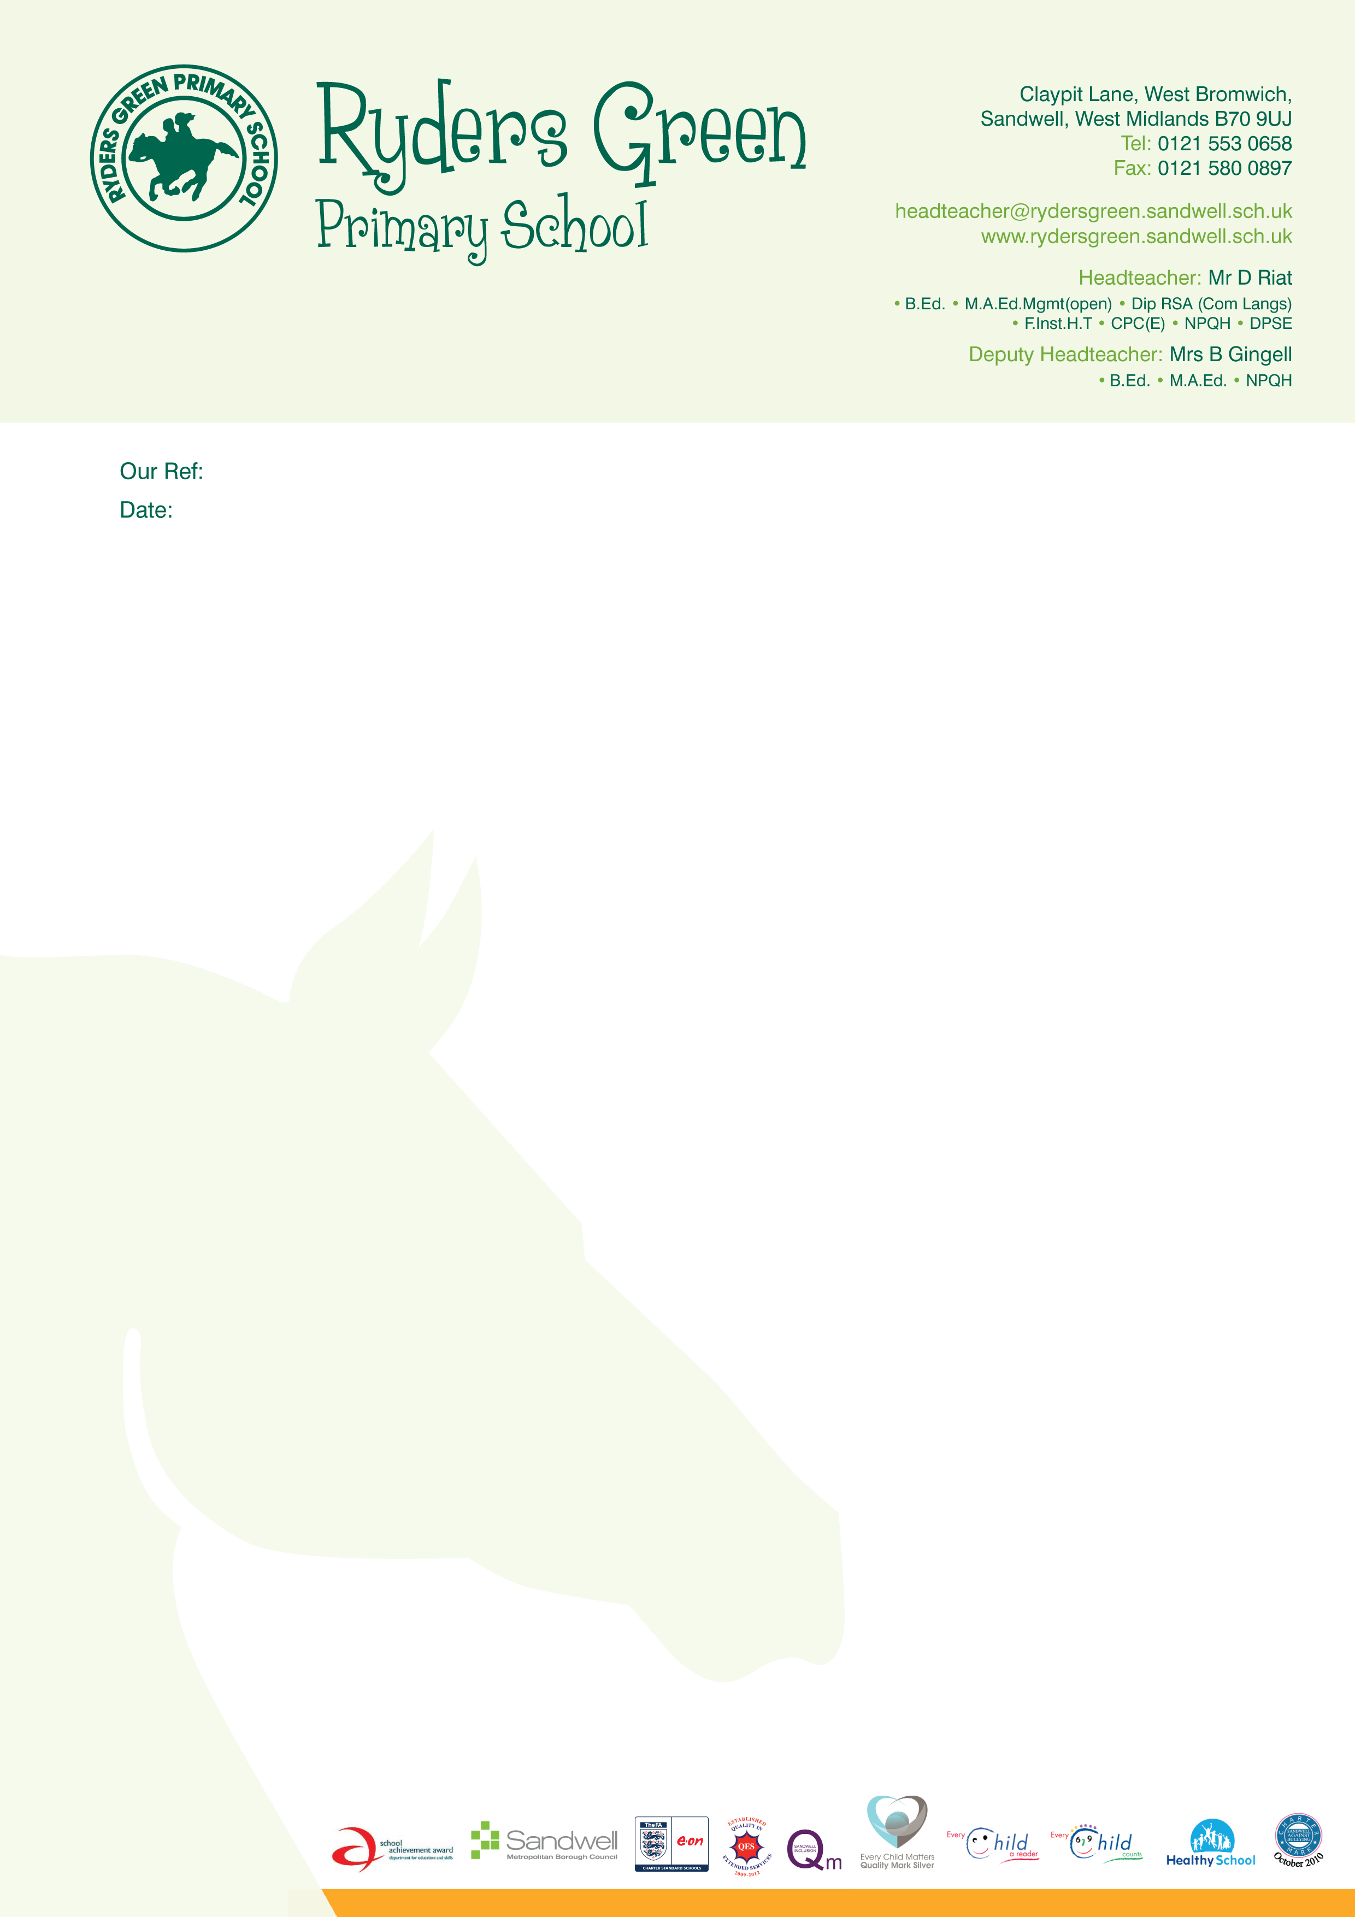


LB/mb/KS1
11th November 2019

Dear Parent / Carer,

Christmas time is almost upon us once again!!

The school kitchen will once again be providing a Christmas dinner for children on Wednesday 11th December.

All KS1 children are entitled to a free universal meal and therefore no payment is required for the Christmas dinner.

However, in order to assist with planning please return the reply slip below indicating your child’s preference.

Reply slips need to be returned to school by Friday 22nd November 2019

Yours sincerely

Miss L Blackmore
Head Teacher

………………………………………………………………………………………………………………………

REPLY SLIP TO BE RETURNED BY FRIDAY 22nd NOVEMBER 2019

Child’s name ________________________ Class _______________

Please (✓) choice
I would like my child to have a Christmas ‘Turkey’ dinner

I would like my child to have a Christmas ‘Vegetarian’ dinner

I would not like my child to have a Christmas dinner and I will be providing them
with a packed lunch

Signed ___________________________________________ Parent / Guardian

www.rydersgreenprimary.co.uk
Contactus@rydersgreen.sandwell.sch.uk

Head Teacher: Miss L Blackmore
⬧ Ba (Hons)  QTS  Pg Cert  AST



