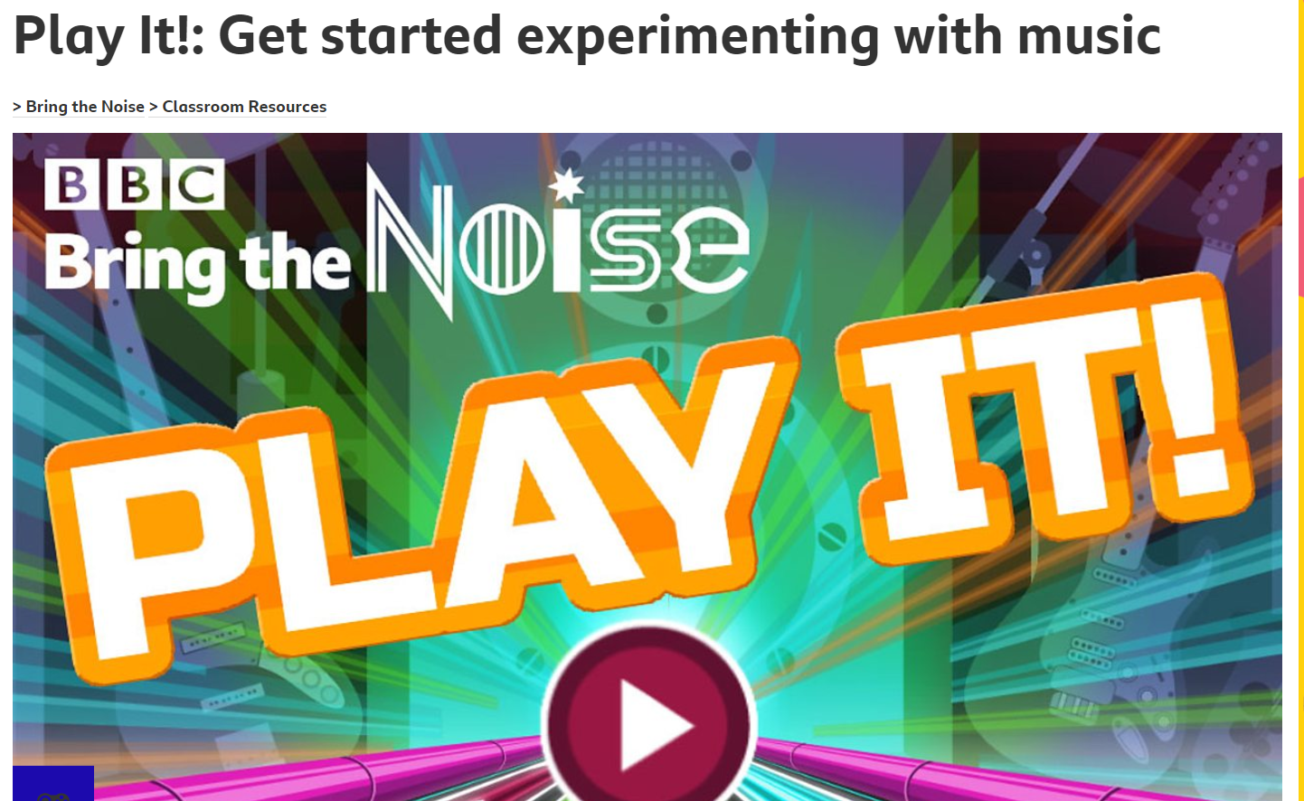

https://www.bbc.co.uk/teach/bring-the-noise/eyfs-ks1-music-play-it-bring-the-noise/z4sq92p

