How to log into your child’s school email account

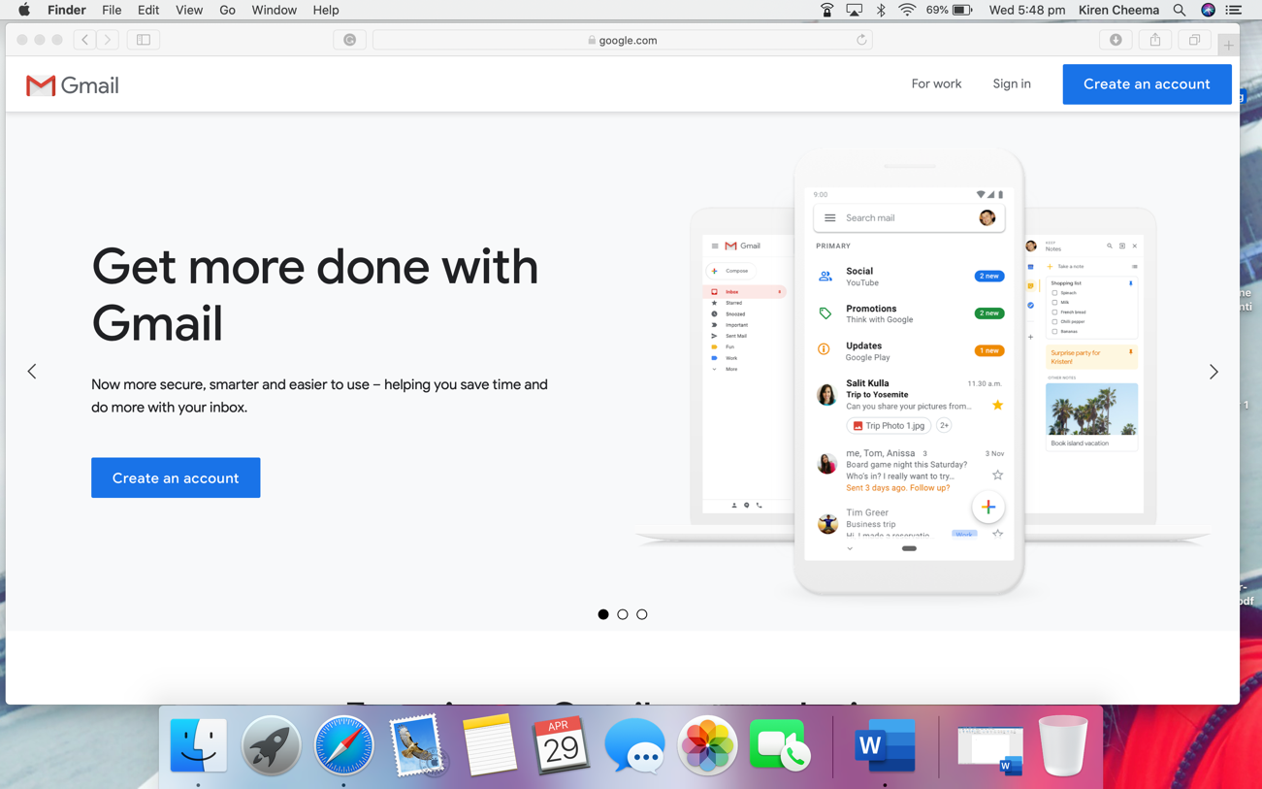
Please go to https://www.google.com/gmail/about/

At the top of the page on the right-hand side click on ‘sign in’.

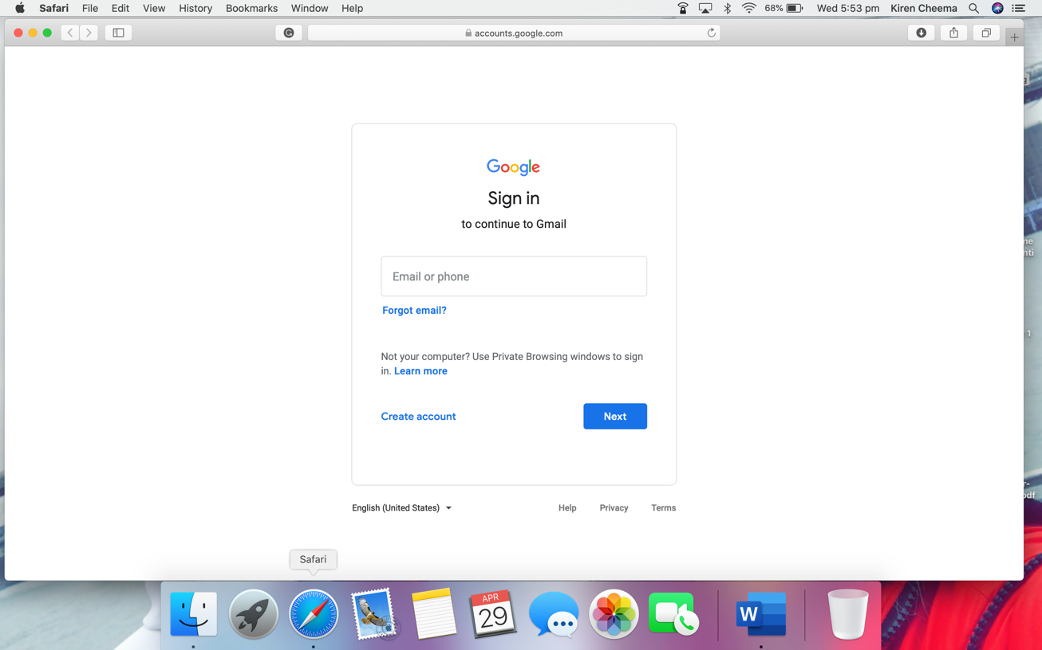
Your child’s email address is their full name broken up with a dot for example:
john.smith@rydersgreen.sandwell.sch.uk please replace the green text with the name of your child with the dot in the middle.

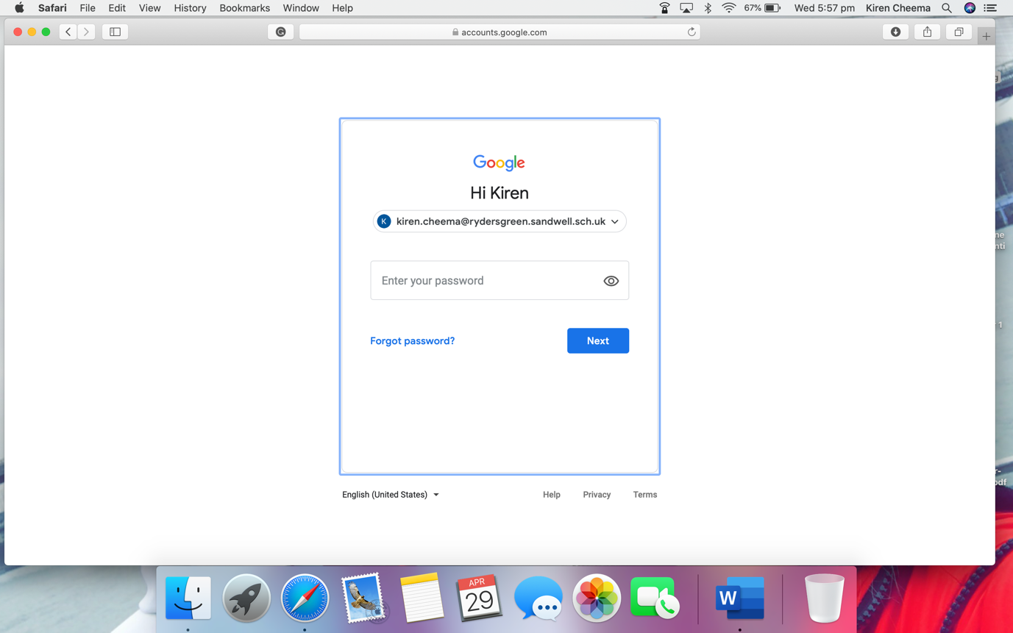
You will then be directed to this page where you will need to enter your child’s password.

If you are unsure of your child’s password, please contact the school so this information can be shared with you confidentially as safeguarding and GDPR is our number one priority.

You must use Gmail to log in. If using an iPad/tablet or smartphone you can download the Gmail app to access these emails if you wish. If you require anymore support, please get in touch.

Thank you

Miss Cheema

