Hairy Faces

What a lot of hairy-faced men there are around nowadays.
When a man grows hair all over his face it is impossible to tell what he really looks like.
Perhaps that's why he does it. He'd rather you didn't know.
Then there's the problem of washing.
When the very hairy ones wash their faces, it must be as big a job as when you and I wash the hair on our heads.
So what I want to know is this. How often do all these hairy-faced men wash their faces? Is it only once a week, like us, on Sunday nights? And do they shampoo it? Do they use a hairdryer? Do they rub hair-tonic in to stop their faces from going bald? Do they go to a barber to have their hairy faces cut and trimmed or do they do it themselves in front of the bathroom mirror with nail-scissors?
I don't know. But next time you see a man with a hairy face (which will probably be as soon as you step out on to the street) maybe you will look at him more closely and start wondering about some of these things.

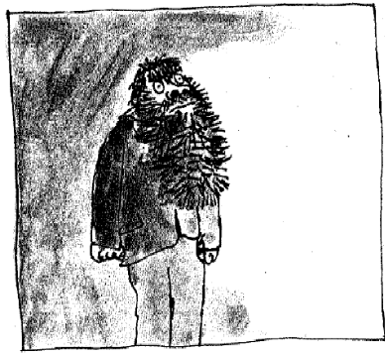

Mr Twit

Mr Twit was one of these very hairy-faced men. The whole of his face except for his forehead, his eyes and his nose, was covered with thick hair. The stuff even sprouted in revolting tufts out of his nostrils and ear-holes.
Mr Twit felt that this hairiness made him look terrifically wise and grand. But in truth he was neither of these things. Mr Twit was a twit. He was born a twit. And now at the age of sixty, he was a bigger twit than ever.
The hair on Mr Twit's face didn't grow smooth and matted as it does on most hairy-faced men. It grew in spikes that stuck out straight like the bristles of a nailbrush.
And how often did Mr Twit wash this bristly nailbrushy face of his?
The answer is never, not even on Sundays.
He hadn't washed it for years.

Dirty Beards

As you know, an ordinary unhairy face like yours or mine simply gets a bit smudgy if it is not washed often enough, and there's nothing so awful about that.
But a hairy face is a very different matter. Things cling to hairs, especially food. Things like gravy go right in among the hairs and stay there. You and I can wipe our smooth faces with a flannel and we quickly look more or less all right again, but the hairy man cannot do that.
We can also, if we are careful, eat our meals without spreading food all over our faces. But not so the hairy man. Watch carefully next time you see a hairy man eating his lunch and you will notice that even if he opens his mouth very wide, it is impossible for him to get a spoonful of beef-stew or ice-cream and chocolate sauce into it without leaving some of it on the hairs.
Mr Twit didn't even bother to open his mouth wide when he ate. As a result (and because he never washed) there were always hundreds of bits of old breakfasts and lunches and suppers sticking to the hairs around his face. They weren't big bits, mind you, because he used to wipe those off with the back of his hand or on his sleeve while he was eating. But if you looked closely (not that you'd ever want to) you would see tiny little specks of dried-up scrambled eggs stuck to the hairs, and spinach and tomato ketchup and fish fingers and minced chicken livers and all the other disgusting things Mr Twit liked to eat.
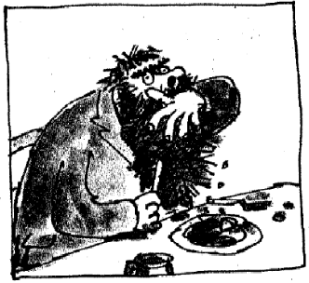

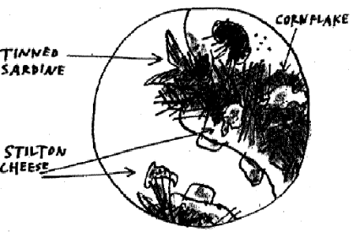

If you looked closer still (hold your noses, ladies and gentlemen), if you peered deep into the moustachy bristles sticking out over his
upper lip, you would probably see much larger objects that had escaped the wipe of his hand, things that had been there for months and months, like a piece of maggoty
green cheese or a mouldy old cornflake or even the slimy tail of a tinned sardine.
Because of all this, Mr Twit never went really hungry. By sticking out his tongue and curling it sideways to explore the hairy jungle around his mouth, he was always able to find a tasty morsel here and there to nibble on.
What I am trying to tell you is that Mr Twit was a foul and smelly old man.
He was also an extremely horrid old man, as you will find out in a moment.

Mrs Twit

Mrs Twit was no better than her husband.
She did not, of course, have a hairy face. It was a pity she didn't because that at any rate would have hidden some of her fearful ugliness.
Take a look at her.
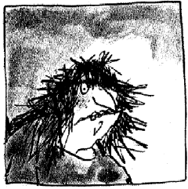

Have you ever seen a woman with an uglier
face than that?
I doubt it. But the funny thing is that Mrs Twit wasn't born ugly. She'd had quite a nice face when she was young. The ugliness
had grown upon her year by year as she got older.
Why would that happen? I'll tell you why.
If a person has ugly thoughts, it begins to show on the face. And when that person has ugly thoughts every day, every week, every year, the face gets uglier and uglier until it gets so ugly you can hardly bear to look at it.

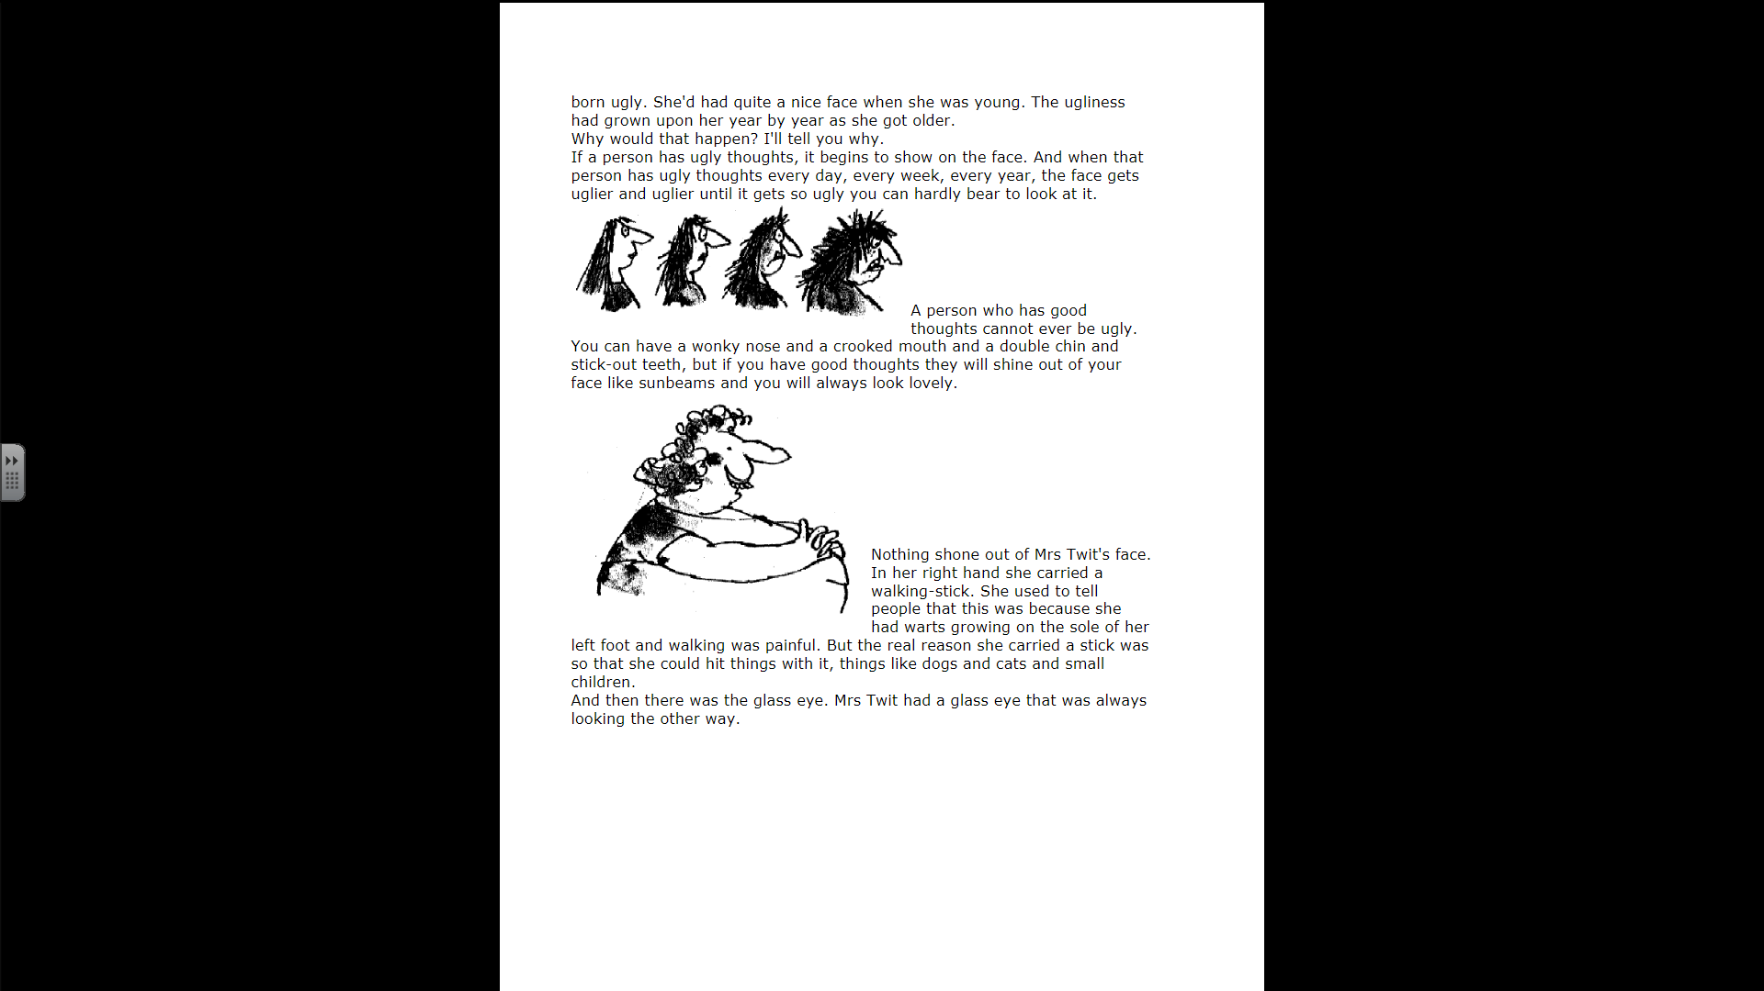
A person who has good thoughts cannot ever be ugly. You can have a wonky nose and a crooked mouth and a double chin and stick-out teeth, but if you have good thoughts they will shine out of your face like sunbeams and you will always look lovely.

Nothing shone out of Mrs Twit's face.
In her right hand she carried a walking-stick. She used to tell people that this was because she had warts growing on the sole of her left foot and walking was painful. But the real reason she carried a stick was so that she could hit things with it, things like dogs and cats and small children.
And then there was the glass eye. Mrs Twit had a glass eye that was always looking the other way.

