Year 2 weekly timetable – Week 3: Monday 20th April 2020
Time | Monday | Tuesday | Wednesday | Thursday | Friday
Before 9am | Morning routine  Get ready for your day! | Morning routine  Get ready for your day! | Morning routine  Get ready for your day! | Morning routine  Get ready for your day! | Morning routine  Get ready for your day!
9am | Go noodle  https://www.youtube.com/watch?v=BQ9q4U2P3ig | Joe Wicks workout  https://www.youtube.com/watch?v=EXt2jLRlaf8 | Go noodle  https://www.youtube.com/watch?v=KhfkYzUwYFk | Joe Wicks workout  https://www.youtube.com/watch?v=d3LPrhI0v-w | Go noodle  https://www.youtube.com/watch?v=dNL6RwymoNg
9.20am | Maths  Practise forming your numbers. 0-9  White rose. Summer Term.  Week 2- Lesson 1- Comparing lengths. Watch the video and complete the activity.  https://whiterosemaths.com/homelearning/year-2/ | TT Rockstars  Use your login details.  Then  Week 2- Lesson 2- Order lengths. Watch the video and complete the activity.  https: //whiterosemaths.com/homelearning/year-2/ | Maths  Practise forming your numbers. 0-9  Week 2- Lesson 3- Four operations with length. Watch the video and complete the activity.  https: //whiterosemaths.com/homelearning/year-2/ | TT Rockstars  Use your login details.  Week 2- Lesson 4- Problem Solving. Watch the video and complete the activity.  https: //whiterosemaths.com/homelearning/year-2/ | Maths  Practise forming your numbers. 0-9  Maths Challenge (first page only):  https://wrm-13b48.kxcdn.com/wp-content/uploads/2020/Problem_of_the_Day/Day-1-Monday-2nd-March-2020.pdf  Then
10am | Break – get some fresh air | Break – get some fresh air | Break – get some fresh air | Break – get some fresh air | Break – get some fresh air
10.20am | Bug Club | Bug Club | Bug Club | Bug Club | Bug Club
10.50am | English  Practise your letter formation  u  Click the link below. There is some information for your grown-ups on the first few pages. Our learning begins on page 4. Complete page 4-6.  https://www.talk4writing.co.uk/wp-content/uploads/2020/04/Y2-Unit.pdf | English  Practise your letter formation  v  Our learning begins on page 6. Complete page 6-7  https://www.talk4writing.co.uk/wp-content/uploads/2020/04/Y2-Unit.pdf  Remember you should be using your neatest handwriting. | English  Our learning begins on page 8. Complete page 8-9  https://www.talk4writing.co.uk/wp-content/uploads/2020/04/Y2-Unit.pdf | English  Practise your letter formation  w x  Our learning begins on page 10. Complete page 10-11. (Page 11, you could match up by writing out or discuss)  https://www.talk4writing.co.uk/wp-content/uploads/2020/04/Y2-Unit.pdf | English  Practise your letter formation  y z  Our learning begins on page 12. Complete page 12  https://www.talk4writing.co.uk/wp-content/uploads/2020/04/Y2-Unit.pdf
11.30am | Lunch | Lunch | Lunch | Lunch | Lunch
12.30pm | Read your school book or a book of your choice.  https://www.oxfordowl.co.uk/for-home/reading/ | Read your school book or a book of your choice.  https://www.oxfordowl.co.uk/for-home/reading/ | Teach your monster to read. Sign in at the top, with the details you have been given.  https://www.teachyourmonstertoread.com/ | Teach your monster to read. Sign in at the top, with the details you have been given.  https://www.teachyourmonstertoread.com/ | Read your school book or a book of your choice.  https://www.oxfordowl.co.uk/for-home/reading/
12.50pm | Pokemon- cosmic yoga.  https://www.youtube.com/watch?v=tbCjkPlsaes | Joe Wicks workout  https://www.youtube.com/watch?v=EXt2jLRlaf8 | Cosmic Yoga- Bear hunt  https://www.youtube.com/watch?v=KAT5NiWHFIU | Joe Wicks workout  https://www.youtube.com/watch?v=d3LPrhI0v-w | Cosmic Yoga- Minecraft  https://www.youtube.com/watch?v=02E1468SdHg
1.20pm | Creative activity – sketching with Rob  https://www.youtube.com/watch?v=fJUgttyqvks | Creative activity – sketching with Rob  https://www.youtube.com/watch?v=4_4-HnAP4IM | Creative activity –sketching with Rob  https://www.youtube.com/watch?v=qPKDfxNo9XQ | Creative activity – sketching with Rob  https://www.youtube.com/watch?v=fj12BZE5FKw | Creative activity – How I’m feeling.  Complete creatively on some paper:  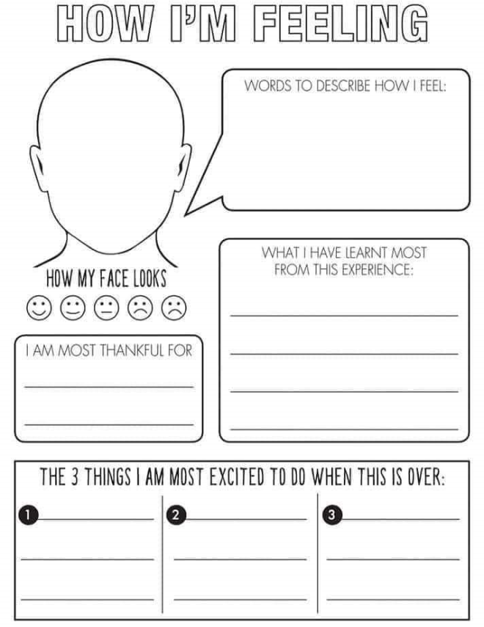
2. 45pm | Spelling shed  Log in at the top.  https://www.edshed.com/en-gb/login?return_url=https%3A%2F%2Fwww.spellingshed.com%2Fen-gb | Spelling shed  Log in at the top.  https://www.edshed.com/en-gb/login?return_url=https%3A%2F%2Fwww.spellingshed.com%2Fen-gb | Spelling shed  Log in at the top.  https://www.edshed.com/en-gb/login?return_url=https%3A%2F%2Fwww.spellingshed.com%2Fen-gb | Reading slot  Class reader / Bug Club | Reading slot  Class reader / Bug Club
3.15pm

Your year group teachers will be available to reply to emails between 9am and 3pm Monday – Friday. During this time, they will be working on other school priorities as well, so you may not get an email reply straight away.

Mrs Trapani luisa.trapani@rydersgreen.sandwell.sch.uk  Miss Kaur sanjeet.kaur@rydersgreen.sandwell.sch.uk  Miss Ebanks kelly.ebanks@rydersgreen.sandwell.sch.uk | Mrs Robinson lisa.robinson@rydersgreen.sandwell.sch.uk  Mrs Leech gwen.leech@ydersgreen.sandwell.sch.uk

