Year 5
Maths

Monday 20th April 2020 – Friday 1st May 2020
Summer Term Weeks 1 & 2

Video tutorials for each lesson can be found at
https://whiterosemaths.com/homelearning/year-5/
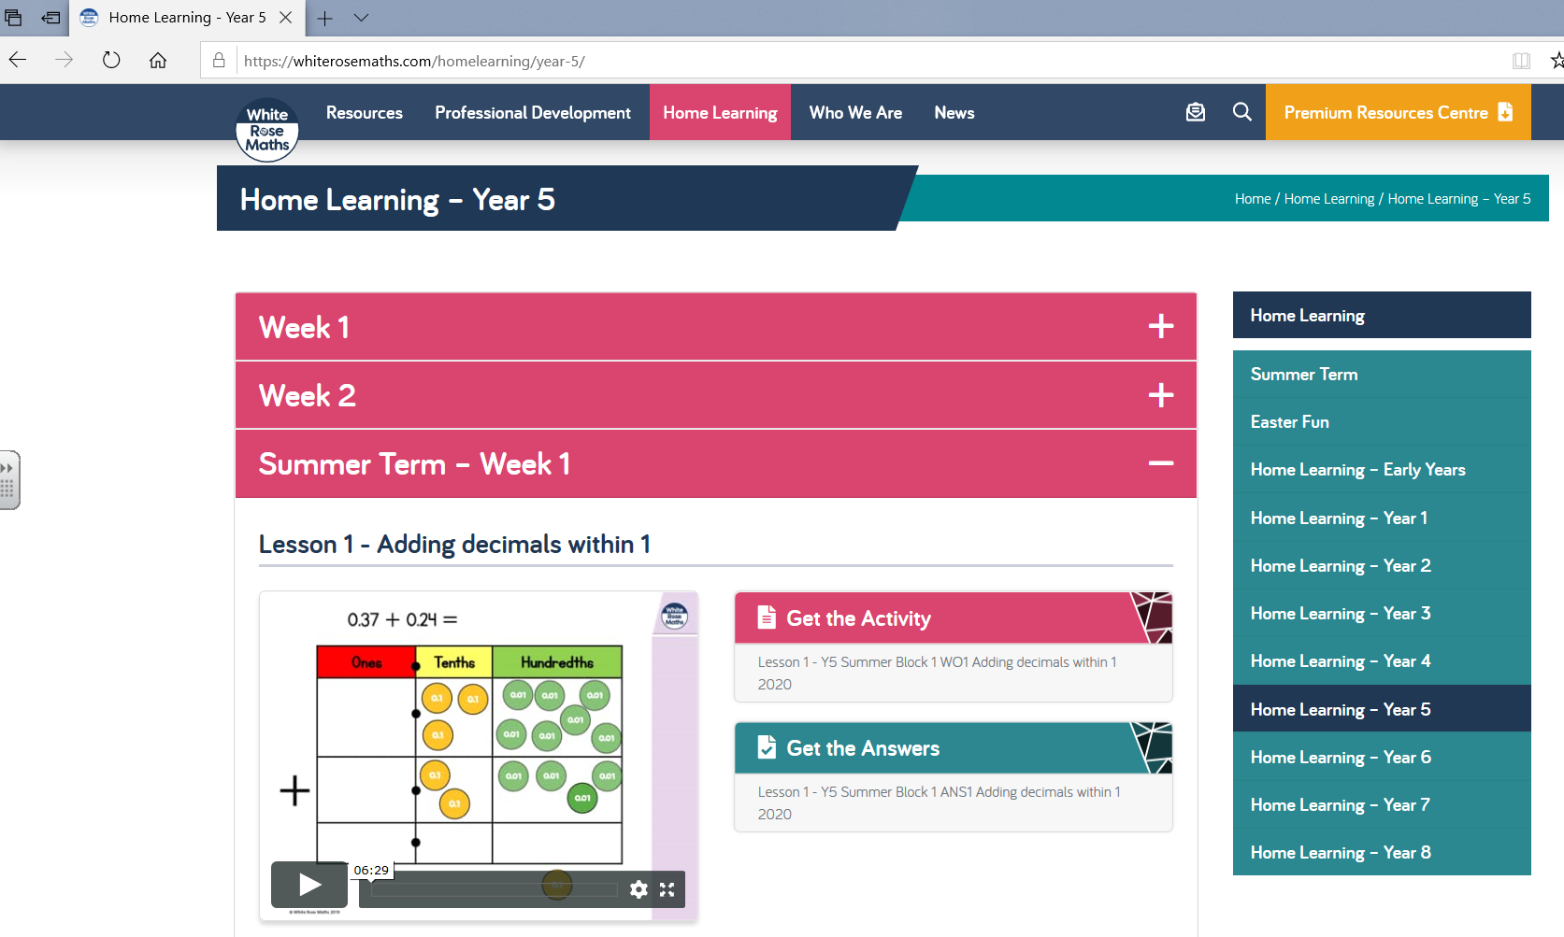
Paper copies of the worksheets are available at school to collect if you would like them.

