Year 6 weekly timetable - Monday 20th April 2020
Time | Monday 20th April | Tuesday 21st April | Wednesday 22nd April | Thursday 23rd April | Friday 24th April
Before 9am | Morning routine | Morning routine | Morning routine | Morning routine | Morning routine
9am | Joe Wicks workout  https://www.youtube.com/watch?v=d3LPrhI0v-w | Joe Wicks workout  https://www.youtube.com/watch?v=EXt2jLRlaf8 | Joe Wicks workout  https://www.youtube.com/watch?v=5MBEyQIlrfo | Joe Wicks workout  https://www.youtube.com/watch?v=d3LPrhI0v-w | Joe Wicks workout  https://www.youtube.com/watch?v=EXt2jLRlaf8
9.30am | English  Sabryna and the River Spirit Daily Reading  Comprehension task 1 | English  Sabryna and the River Spirit Daily Reading  Comprehension task 2 | English  Sabryna and the River Spirit Daily Reading  Comprehension task 3 | English  Sabryna and the River Spirit Daily Reading  Comprehension task 4 | English  Sabryna and the River Spirit Daily Reading  Comprehension task 5
10.15am | Break – get some fresh air | Break – get some fresh air | Break – get some fresh air | Break – get some fresh air | Break – get some fresh air
10.30am | Bug Club | Bug Club | Bug Club | Bug Club | Bug Club
10.45am  11.45am | Maths  https://whiterosemaths.com/homelearning/year-6/  Summer 1 – Lesson 1  Vertically opposite angles | Maths  https://whiterosemaths.com/homelearning/year-6/  Summer 1 – Lesson 2  Angles in a Triangle | Maths  https://whiterosemaths.com/homelearning/year-6/  Summer 1 – Lesson 3  Angles in a Triangle Special Cases | Maths  https://whiterosemaths.com/homelearning/year-6/  Summer 1 – Lesson 4  Angles in a Triangle  Missing Angles | Maths  https://whiterosemaths.com/homelearning/year-6/  Summer 1 – Lesson 5  Maths Challenge
11.45-12pm | ERIC | ERIC | ERIC | ERIC | ERIC
12pm-12.30pm | SPaG  Century Tech | SPaG  Century Tech | SPaG  Century Tech | SPaG  Century Tech | SPaG  Century Tech
1.30pm-2.30pm | History  Today you are going to look into the battle between the Ancient Greeks and the Persian Army  Open up Monday 20th History powerpoint where you will find your activities and relevant information you require. | History/Art  Today you are going to follow on from yesterday’s work to incorporate some art work – open up the powerpoint Tuesday 21st your activities and information are on the slides.  Ancient Green Pottery design | PSHE  Open up Wednesday PSHE Bullying powerpoint, read and answer the relevant questions throughout | PE  https://www.yogadownload.com/Utilities/GenericProductDisplay/tabid/110/prodid/1687/default.aspx#.XpiAekBFzIU  This can be done with other members of your family | Art  Search ‘1 Point Perspective- Art Class with Mr. Noah’ on youtube, use the demonstration to help you.  Can you now draw 3D shapes from a 1 point perspective? Add tone to create depth and shade.  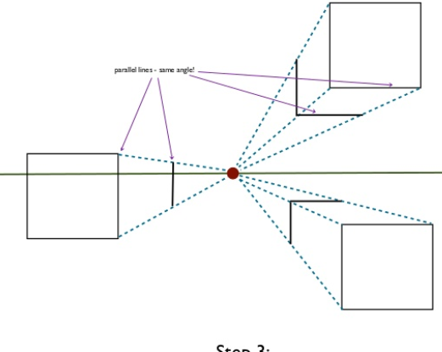
2.30pm-3pm | Creative activity –  http://www.robbiddulph.com/draw-with-rob | Creative activity –  http://www.robbiddulph.com/draw-with-rob | Creative activity –  http://www.robbiddulph.com/draw-with-rob | Creative activity –  http://www.robbiddulph.com/draw-with-rob | Creative activity –  http://www.robbiddulph.com/draw-with-rob
3p;m-3.15pm | Newsround  https://www.bbc.co.uk/newsround/news/watch_newsround  Send an email to your class teacher with your opinion of the news of the day. | Newsround  https://www.bbc.co.uk/newsround/news/watch_newsround  Send an email to your class teacher with your opinion of the news of the day. | Newsround  https://www.bbc.co.uk/newsround/news/watch_newsround  Send an email to your class teacher with your opinion of the news of the day. | Newsround  https://www.bbc.co.uk/newsround/news/watch_newsround  Send an email to your class teacher with your opinion of the news of the day. | Newsround  https://www.bbc.co.uk/newsround/news/watch_newsround  Send an email to your class teacher with your opinion of the news of the day.
3.15pm | End of school day – don’t forget that you should still read your home reader to your parents/ carers | End of school day – don’t forget that you should still read your home reader to your parents/ carers | End of school day – don’t forget that you should still read your home reader to your parents/ carers | End of school day – don’t forget that you should still read your home reader to your parents/ carers | End of school day – don’t forget that you should still read your home reader to your parents/ carers

Your year group teachers will be available to reply to emails between 9am and 3.30pm Monday – Friday. During this time, they will be working on other school priorities as well, so you may not get an emailed reply straight away. Any emails after 3.30pm will be replied to the following morning and if emails are received over the weekend you will receive a reply on Monday morning.

Miss Adams rebecca.adams@rydersgreen.sandwell.sch.uk  Miss Allen rebecca.allen@rydersgreen.sandwell.sch.uk | Miss Randle samantha.randle@rydersgreen.sandwell.sch.uk  Miss Garrington faye.garrington@rydersgreen.sandwell.sch.uk  Any technical support you may require or if you are having any problems with your logins please contact:  Miss Johal angela.johal@rydersgreen.sandwell.sch.uk

