Year 6 weekly timetable - Monday 30th March 2020
Time | Monday 30th March | Tuesday 31st March | Wednesday 1st April | Thursday 2nd April | Friday 3rd April
Before 9am | Morning routine | Morning routine | Morning routine | Morning routine | Morning routine
9am | Joe Wicks workout  https://www.youtube.com/watch?v=d3LPrhI0v-w | Joe Wicks workout  https://www.youtube.com/watch?v=EXt2jLRlaf8 | Joe Wicks workout  https://www.youtube.com/watch?v=5MBEyQIlrfo | Joe Wicks workout  https://www.youtube.com/watch?v=d3LPrhI0v-w | Joe Wicks workout  https://www.youtube.com/watch?v=EXt2jLRlaf8
9.30am | English  https://www.topmarks.co.uk/easter/easterstory.aspx  Read the Easter Story and generate your own questions (a mixture of 1,2 and 3 mark questions) that you could ask, along with the answers to support it.  Find the meaning of any unfamiliar words.  For those of you unable to access the Easter work you can read a section of your favourite book you have got and generate your questions and look up unfamiliar words using this. | English  https://www.topmarks.co.uk/easter/easterstory.aspx  Recap the Easter Story and re-create it in the form of a comic strip which uses both pictures and comments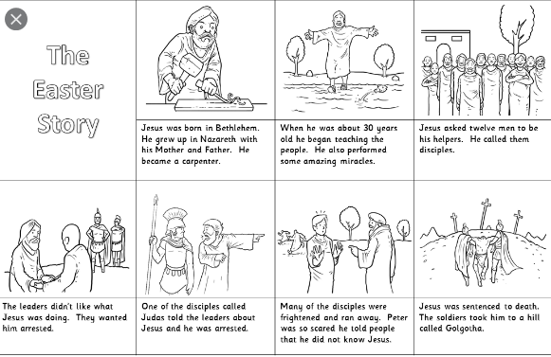  For those of you unable to access the Easter work you can create an alternative comic strip of your favourite book you are reading at the moment. | English  https://www.topmarks.co.uk/easter/easterstory.aspx  Continue with your comic strips from the day before and email a picture if possible to your class teacher of your finished comic strip. | English  Century Tech – complete two nuggets of your choice  Email your class teacher to let them know what you have been working on and things you have found most difficult. | English  Use the image below to create your own short story. This needs to include the following:  - Paragraphs  - Semi-colons  - Commas  - Adjectives  - Adverbial phrases  - Relative clauses  
10.15am | Break – get some fresh air | Break – get some fresh air | Break – get some fresh air | Break – get some fresh air | Break – get some fresh air
10.30am | Bug Club | Bug Club | Bug Club | Bug Club | Bug Club
10.45am  11.45am | Maths  https://www.topmarks.co.uk/maths-games/11-14-years/number  Complete the online games and problem solving questions linked to number | Maths  https://www.topmarks.co.uk/maths-games/11-14-years/algebra  Complete the online games and problem solving questions linked to algebra | Maths  https://www.topmarks.co.uk/maths-games/11-14-years/money  Complete the online games and problem solving questions linked to money. | Maths https://www.topmarks.co.uk/maths-games/11-14-years/shape-position-and-movement  Complete the online games and problem solving questions linked to shape – position and movement | Maths  Century Tech – complete two nuggets of your choice  Send an email to your class teacher to let them know the two nuggets you have completed, and provide two stars and a wish of two things you did well and an area of improvement.
11.45-12pm | ERIC | ERIC | ERIC | ERIC | ERIC
12pm-12.30pm | SPaG  Century Tech | SPaG  Century Tech | SPaG  Century Tech | SPaG  Century Tech | SPaG  Century Tech
1.30pm-2.30pm | History  Research task – take a look at the history behind the story of Easter and how Easter Eggs and the story of the Easter bunny came about.  This can be presented on a word document, leaflet or poster. | NHS ART WORK  This is your opportunity to create your rainbow and display it in your window at home to support the NHS during this difficult time.  You can get creative with these, some people have created wind chimes using toilet roll holders, painted pictures or even knitted them. Have a go and have some fun! | Design your own Easter Egg  This can be the egg itself and the box it comes in.  If you are supervised by a parent/carer you could even get creative by decorating an actual egg or use a balloon and cover in paper and glue and make and decorate a large egg.  Send an email to your class teacher with a picture of you are able to with your creation. | DT  Write up ingredients, intructions, diagram (labelled) and method for making your own Easter fairy cakes either in your topic work book or on a piece of paper  If you have the supervision of an adult you can carry out your method and even email a picture of your finished cakes to your class teacher. | Easter Cards  Get as creative as you want with these – email the designs to your class teacher
2.30pm-3pm | Creative activity –  http://www.robbiddulph.com/draw-with-rob | Creative activity –  http://www.robbiddulph.com/draw-with-rob | Creative activity –  http://www.robbiddulph.com/draw-with-rob | Creative activity –  http://www.robbiddulph.com/draw-with-rob | Creative activity –  http://www.robbiddulph.com/draw-with-rob
3p;m-3.15pm | Newsround  https://www.bbc.co.uk/newsround/news/watch_newsround  Send an email to your class teacher with your opinion of the news of the day. | Newsround  https://www.bbc.co.uk/newsround/news/watch_newsround  Send an email to your class teacher with your opinion of the news of the day. | Newsround  https://www.bbc.co.uk/newsround/news/watch_newsround  Send an email to your class teacher with your opinion of the news of the day. | Newsround  https://www.bbc.co.uk/newsround/news/watch_newsround  Send an email to your class teacher with your opinion of the news of the day. | Newsround  https://www.bbc.co.uk/newsround/news/watch_newsround  Send an email to your class teacher with your opinion of the news of the day.
3.15pm | End of school day – don’t forget that you should still read your home reader to your parents/ carers | End of school day – don’t forget that you should still read your home reader to your parents/ carers | End of school day – don’t forget that you should still read your home reader to your parents/ carers | End of school day – don’t forget that you should still read your home reader to your parents/ carers | End of school day – don’t forget that you should still read your home reader to your parents/ carers

Your year group teachers will be available to reply to emails between 9am and 3.30pm Monday – Friday. During this time, they will be working on other school priorities as well, so you may not get an emailed reply straight away. Any emails after 3.30pm will be replied to the following morning and if emails are received over the weekend you will receive a reply on Monday morning.

Miss Adams rebecca.adams@rydersgreen.sandwell.sch.uk  Miss Allen rebecca.allen@rydersgreen.sandwell.sch.uk | Miss Randle samantha.randle@rydersgreen.sandwell.sch.uk  Miss Garrington faye.garrington@rydersgreen.sandwell.sch.uk  Any technical support you may require or if you are having any problems with your logins please contact:  Miss Johal angela.johal@rydersgreen.sandwell.sch.uk

