|  |  |  |
| --- | --- | --- |
| Read your favourite story | Play outside | Do a funny dance |
| Do some activities on StudyLadder | Do some junk modelling | Play with your toys |
| Draw a picture | Help do some cooking | Do some yoga- cosmic kids on YouTube is great |
| Write a letter to your family and friends | Help around the house | Watch your favourite film |

Flat Teacher

Here are some fun ideas of activities that you and your flat teacher could do. Can you take photos or videos of you doing these or any other ideas you have and upload them onto Tapestry or send them in an email to [leah.cartwright@rydersgreen.sandwell.sch.uk](mailto:leah.cartwright@rydersgreen.sandwell.sch.uk)

I can’t wait to see them

Miss Cartwright

Adventure

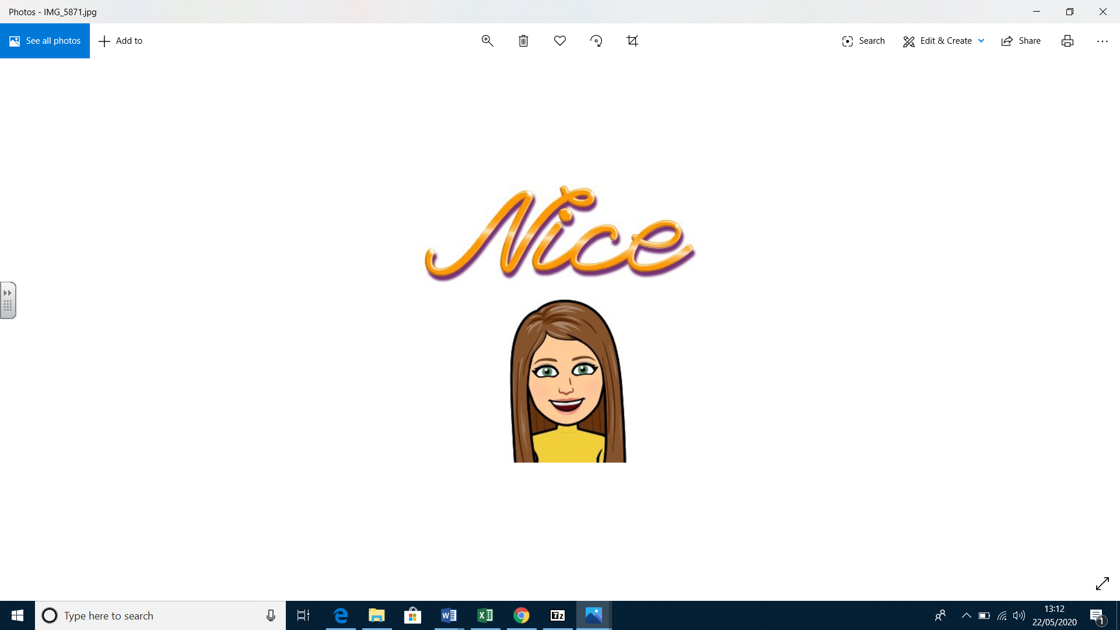

with Miss Cartwright