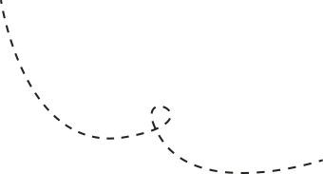

Miss Cheema

Claypit Lane

Ryders Green Primary School

Dear RKC,

I have been thinking about you and all of the fun times we have together at school. I miss you a lot so I have sent you a surprise. I have made a mini ‘me’ so that we can still learn, play and grow together!

I want to see what you are doing each day so take me along on your adventures! I’m a super helper and I’d love to see what you’ve been learning about. I can’t wait to listen to you read and to be amazed by what you can do.

Remember to keep me safe and to bring me along to all of your home learning.

We will be back together before you know it and you can share all of your news with your friends. I can’t wait to hear your stories!

Stay safe and work hard,

Miss Cheema