Year 6 weekly timetable - Monday 1st June 2020
Time | Monday 1st June | Tuesday 2nd June | Wednesday 3rd June | Thursday 4th June | Friday 5th June
Before 9am | Morning routine | Morning routine | Morning routine | Morning routine | Morning routine
9am | Joe Wicks workout  https://www.youtube.com/watch?v=d3LPrhI0v-w | Joe Wicks workout  https://www.youtube.com/watch?v=EXt2jLRlaf8 | Joe Wicks workout  https://www.youtube.com/watch?v=5MBEyQIlrfo | Joe Wicks workout  https://www.youtube.com/watch?v=d3LPrhI0v-w | Joe Wicks workout  https://www.youtube.com/watch?v=EXt2jLRlaf8
9.30am | English  Independent English Activity book  The Five Palms Hotel  Identify and find the meaning of unfamiliar words, highlight key points from the text and answer the comprehension questions  Pages 14 and 15 | English  Independent English Activity book  Spot Mr Whoops mistakes in the text.  Up-level Mr Whoop’s paragraph and correct mistakes that you have spotted  Page 16 | English  Independent English Activity book  Quick Write – Space  This should be at least half a page, ensure you have punctuated correctly and included paragraphs and up-levelled vocabulary  Page 17 | English  Independent English Activity book  Word search – World War Two and SPaG problem solving activities including clues 1 and 2  Pages 18,19,20,21 and 22 | English  Independent English Activity book  SPaG problem solving activities continued, Clues 3, 4 and 5  Pages 23, 24 and 25
10.15am | Break – get some fresh air | Break – get some fresh air | Break – get some fresh air | Break – get some fresh air | Break – get some fresh air
10.30am | Bug Club | Bug Club | Bug Club | Bug Club | Bug Club
10.45am  11.45am | Maths  Independent Maths Activity book  Pirate Mental Calculations, code breaking and activity mat. These can be done in your maths books or the booklet can be printed off for you to work from.  Pages 1,2 and 3 | Maths  Independent Maths Activity book  Pirate Flags and mental calculations Mosaics, please complete pages 4,5 and 6 | Maths  Independent Maths Activity book  Mental calculations and accuracy Mosaics and The Mystery of the missing treasure. Please complete pages 7,8 and 9 | Maths  Independent Maths Activity book  Checking Calculations – clue 1 and clue 2 please complete the activities on pages 10 and 11  Extension – have a go at the would you rather question | Maths  Independent Maths Activity book  Checking Calculations – clue 3 and clue 4 please complete the activities on pages 12 and 13  Extension – have a go at the multiple maze question
11.45-12pm | ERIC | ERIC | ERIC | ERIC | ERIC
12pm-12.30pm | SPaG  Century Tech | SPaG  Century Tech | SPaG  Century Tech | SPaG  Century Tech | SPaG  Century Tech
1.30pm-2.30pm | Science  Animals including Humans  Circulatory System  Go through the powerpoint to gain key information and facts  Complete the activity sheets 1,2 and 3 | ICT  Spreadsheets  Data, formula and cells  Go through the powerpoint and follow the guidance in having a go at Microsoft Excel in adding your own data, formula and cells  Complete the data input activity – activity 1  Complete the data activity sheet, this is differentiated by stars to state level of difficulty. Choose one that suits you best – activity 2 | RE  Justice and Freedom  Go through the powerpoint and gather key information on the topic  Activity 1 – what is freedom? This is differentiated by stars so choose your level of difficulty  Activity 2 – Views on freedom, have a look at all the different religions and their views on freedom, what are the similarities and differences? Why do we all have different opinions on what freedom is? Write a paragraph to explain in your topic books | PSHE  Transition  Please complete the following activities to get you thinking about your upcoming transition to Secondary School. These activities may put your mind at rest and allow you to discuss and talk about any concerns of questions you have about your new schools.  Activity 1 – My feelings about secondary school  Activity 2 – School Scenarios  Activity 3 – researching and getting to know my new school  You can always email your class teacher with any questions you have about your transition or any worries or concerns you may have. | Art  Now that we are allowed out to parks and have a little more freedom use this as an opportunity to find a beautiful landscape maybe in your local park and sketch the scenery. Please ensure you are accompanied by your adult. If this is not possible you can always sketch your image from your garden – choose a nice section in the garden to focus on or even google and find a landscape you would like to draw.  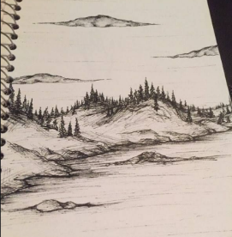  Send a picture to your class teacher. 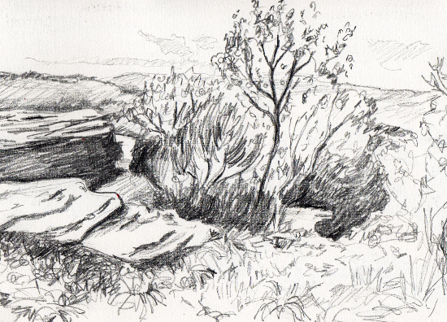
2.30pm-3pm | Creative activity –  http://www.robbiddulph.com/draw-with-rob | Creative activity –  http://www.robbiddulph.com/draw-with-rob | Creative activity –  http://www.robbiddulph.com/draw-with-rob | Creative activity –  http://www.robbiddulph.com/draw-with-rob | Creative activity –  http://www.robbiddulph.com/draw-with-rob
3p;m-3.15pm | Newsround  https://www.bbc.co.uk/newsround/news/watch_newsround  Send an email to your class teacher with your opinion of the news of the day. | Newsround  https://www.bbc.co.uk/newsround/news/watch_newsround  Send an email to your class teacher with your opinion of the news of the day. | Newsround  https://www.bbc.co.uk/newsround/news/watch_newsround  Send an email to your class teacher with your opinion of the news of the day. | Newsround  https://www.bbc.co.uk/newsround/news/watch_newsround  Send an email to your class teacher with your opinion of the news of the day. | Newsround  https://www.bbc.co.uk/newsround/news/watch_newsround  Send an email to your class teacher with your opinion of the news of the day.
3.15pm | End of school day – don’t forget that you should still read your home reader to your parents/ carers | End of school day – don’t forget that you should still read your home reader to your parents/ carers | End of school day – don’t forget that you should still read your home reader to your parents/ carers | End of school day – don’t forget that you should still read your home reader to your parents/ carers | End of school day – don’t forget that you should still read your home reader to your parents/ carers

Your year group teachers will be available to reply to emails between 9am and 3.30pm Monday – Friday. During this time, they will be working on other school priorities as well, so you may not get an emailed reply straight away. Any emails after 3.30pm will be replied to the following morning and if emails are received over the weekend you will receive a reply on Monday morning.

Miss Adams rebecca.adams@rydersgreen.sandwell.sch.uk  Miss Allen rebecca.allen@rydersgreen.sandwell.sch.uk | Miss Randle samantha.randle@rydersgreen.sandwell.sch.uk  Miss Garrington faye.garrington@rydersgreen.sandwell.sch.uk  Any technical support you may require or if you are having any problems with your logins please contact:  Miss Johal angela.johal@rydersgreen.sandwell.sch.uk

