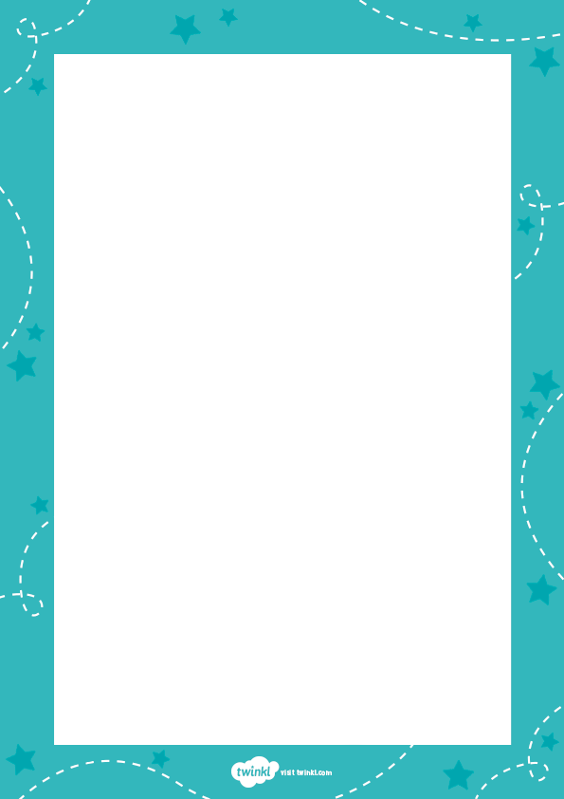

**Your Flat Teacher**

My favourite thing

about watching you grow

is hearing your stories

and the facts that you know.

But now, for a while,

we must stay far apart.

Regardless of distance,

you’re still in my heart.

I think of you daily

and miss you a lot.

So, I’ve made you a ‘me’

that’s a tiny mascot!

Look at your flat teacher –

a miniature me!

I’ll help with your learning

and see what you see.

I’ll join you on journeys

wherever you roam

and spend some time with you

when you’re safe at home.

You’ll bring me to lessons

when we meet online

and we’ll be together

when things are just fine.