1. Follow this link:
https://www.thenational.academy/online-classroom
2. Click “schedule”.
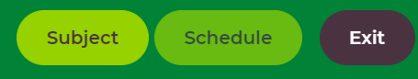
3. Click “Year 4”.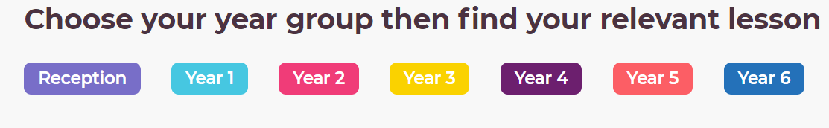
4. Choose the correct day of the week and choose the correct subject (English or maths).
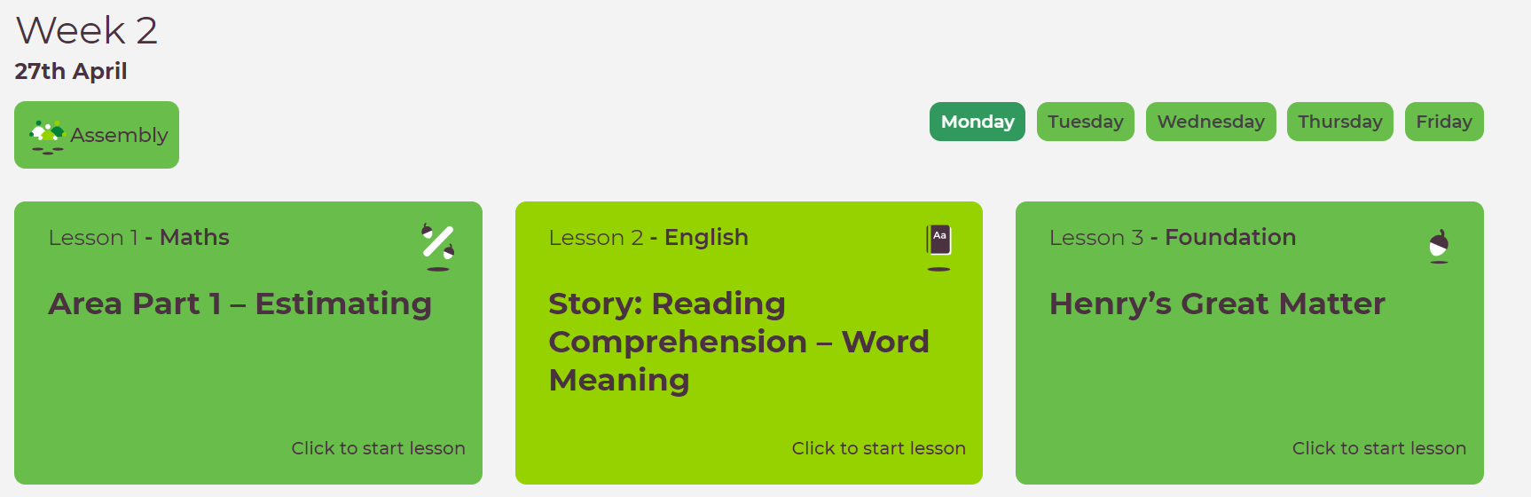

5. Follow the videos and activities to complete that lesson.

