Year 2 weekly timetable : Monday 1st June 2020
Time | Monday | Tuesday | Wednesday | Thursday | Friday
Before 9am | Morning routine  Get ready for your day! | Morning routine  Get ready for your day! | Morning routine  Get ready for your day! | Morning routine  Get ready for your day! | Morning routine  Get ready for your day!
9am | Joe Wicks  https://www.youtube.com/watch?v=pnKCGY9ZocA | Joe Wicks  https://www.youtube.com/watch?v=SbFqQarDM50 | Go noodle  https://www.youtube.com/watch?v=ok7V1pWtRzs | Joe Wicks  https://www.youtube.com/watch?v=YIB2SJnBHBQ&list=PLyCLoPd4VxBvPHOpzoEk5onAEbq40g2-k&index=3 | Go noodle  https://www.youtube.com/watch?v=vPccTY3sph4
9.20am | Maths  https://whiterosemaths.com/homelearning/year-2/  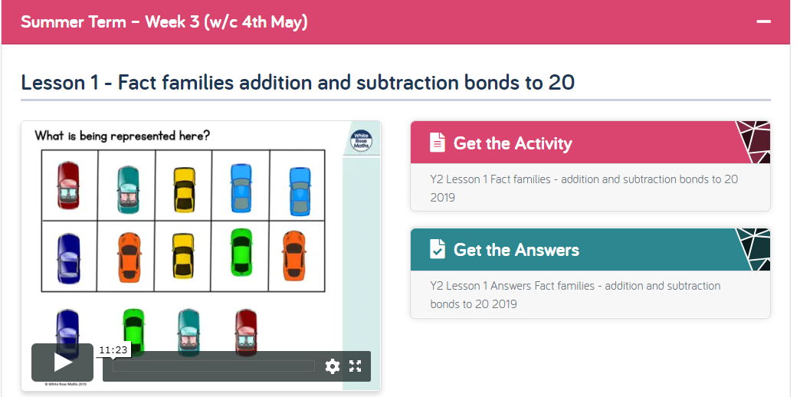  Summer Term Week 3 (wc 4th May)  Fact families | TT Rockstars  Use your login details.  Maths:  https://whiterosemaths.com/homelearning/year-2/  Lesson 2  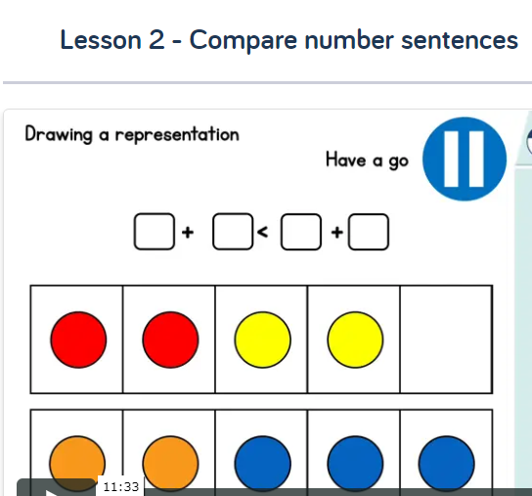 | Maths  Practise forming your numbers. 0-9  https://whiterosemaths.com/homelearning/year-2/  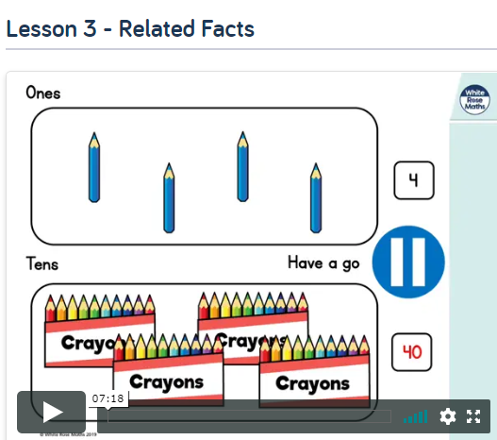 | TT Rockstars  Use your login details.  Maths:  https://whiterosemaths.com/homelearning/year-2/  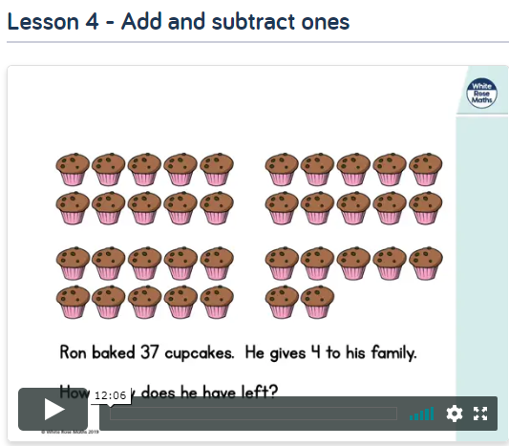 | Maths  Practise forming your numbers. 0-9  1 page of your Maths booklet  Maths  https://whiterosemaths.com/homelearning/year-2/  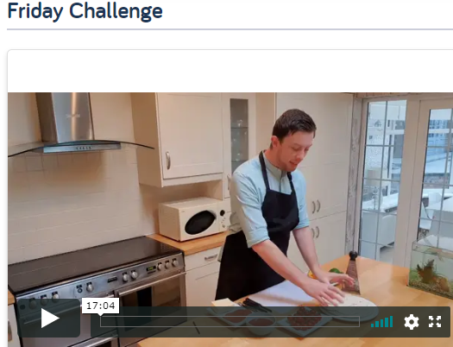
10am | Break – get some fresh air | Break – get some fresh air | Break – get some fresh air | Break – get some fresh air | Break – get some fresh air
10.20am | Bug Club | Spelling Shed- Play some of our games.  https://www.spellingshed.com/en-gb | Bug Club | Spelling Shed- Play some of our games.  https://www.spellingshed.com/en-gb | Bug Club
10.50am | English  Practise your letter formation  j  Our next story is called Adventures are the Pits.  Have a look at the picture below. Write a prediction of what the story might be about, where the boy is? What are the pits? How is the boy feeling in the image? How do you know?  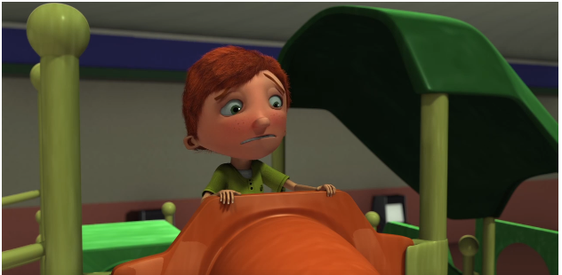 | English  Practise your letter formation  k  Watch- Adventures are the pits.  https://www.literacyshed.com/adventures-are-the-pits.html  Have a go at writing the answers to these questions down, neatly. Watch the video as many times as you need to?  - Why is the boy scared to go down the slide?  - What is the writer trying to tell us?  - What is the main character scared of /nervous about?  - Did the slide end where you thought it would?  - What did the boy have to overcome in order to get out?​ | English  Practise your letter formation  l  Write a blub for this book. What is the story about?  Create a mindmap of all the feelings you think the boy felt throughout the story. If you can, find synonyms for these words.  https://www.collinsdictionary.com/dictionary/english-thesaurus  Create another mindmap with any adjectives you could use to describe the boy/the ball pit/ the objects found in the darkness. | English  Practise your letter formation  m  Today you will be rewriting this story. Remember to include some of the feelings and adjectives you came up with yesterday.  Challenge: Can you change the story slightly? Where could the ballpit slide take you? | English  Practise your letter formation  n  Complete and check your story. Is your vocabulary impressive or can you up-level using a synonym?  Find a verb in your story and use an adverb (quickly, slowly to describe how the boy slid down the slide) Some examples below:  Link to a Thesaurus for synonyms  https://www.collinsdictionary.com/dictionary/english-thesaurus  We would love to see your stories, you could take a picture and email them if you like. Once you are finished draw a picture to go with your work.
11.30am | Lunch | Lunch | Lunch | Lunch | Lunch
12.30pm | Read your school book or a book of your choice.  https://www.oxfordowl.co.uk/for-home/reading/ | Read your school book or a book of your choice.  https://www.oxfordowl.co.uk/for-home/reading/ | Read your school book or a book of your choice.  https://www.oxfordowl.co.uk/for-home/reading/ | Read your school book or a book of your choice.  https://www.oxfordowl.co.uk/for-home/reading/ | Read your school book or a book of your choice.  https://www.oxfordowl.co.uk/for-home/reading/
12.50pm | Sketch with Rob- Hector  https://www.youtube.com/watch?v=WR55SUFtfz0 | Cosmic Yoga- Disco  https://www.youtube.com/watch?v=23VdtT0vQUY | Sketch with Rob- Sloth  https://www.youtube.com/watch?v=aRpkdQ_gD1c | Dance-a-long- Rainbows  https://www.youtube.com/watch?v=tbPGvZDNoY0 | Just dance- I’m a Gummy Bear  https://www.youtube.com/watch?v=6Q7-tzCCh3w
1.20pm | Science- 6. What a Gas!  https://pstt.org.uk/resources/curriculum-materials/Science-Fun-at-Home | Science-5. Spider Safari  https://pstt.org.uk/resources/curriculum-materials/Science-Fun-at-Home | Science-4. Sink or Swim?  https://pstt.org.uk/resources/curriculum-materials/Science-Fun-at-Home | Science-3. Egg-citing Science  https://pstt.org.uk/resources/curriculum-materials/Science-Fun-at-Home | Science- 2. Spinning Science  https://pstt.org.uk/resources/curriculum-materials/Science-Fun-at-Home
2. 45pm | Listen to If I were an astronaut. A story read on a spaceship!  https://storytimefromspace.com/if-i-were-an-astronaut-2/ | Reading slot  Class reader / Bug Club | Reading slot  Class reader / Bug Club | Reading slot  Class reader / Bug Club | Reading slot  Class reader / Bug Club
3.15pm

Your year group teachers will be available to reply to emails between 9am and 3pm Monday – Friday. During this time, they will be working on other school priorities as well, so you may not get an emailed reply straight away.

Mrs Trapani luisa.trapani@rydersgreen.sandwell.sch.uk  Miss kaur sanjeet.kaur@rydersgreen.sandwell.sch.uk  Miss Ebanks kelly.ebanks@rydersgreen.sandwell.sch.uk | Mrs Robinson lisa.robinson@rydersgreen.sandwell.sch.uk  Mrs leech gwen.leech@ydersgreen.sandwell.sch.uk

