Year 2 weekly timetable – 29th June 2020
Time | Monday | Tuesday | Wednesday | Thursday | Friday
Before 9am | Morning routine  Get ready for your day! | Morning routine  Get ready for your day! | Morning routine  Get ready for your day! | Morning routine  Get ready for your day! | Morning routine  Get ready for your day!
9am | Joe Wicks workout  https://www.youtube.com/watch?v=d3LPrhI0v-w | Joe Wicks workout  https://www.youtube.com/watch?v=EXt2jLRlaf8 | Joe Wicks workout  https://www.youtube.com/watch?v=5MBEyQIlrfo | Joe Wicks workout  https://www.youtube.com/watch?v=d3LPrhI0v-w | Joe Wicks workout  https://www.youtube.com/watch?v=EXt2jLRlaf8
9.20am | Maths  https://whiterosemaths.com/homelearning/year-2/  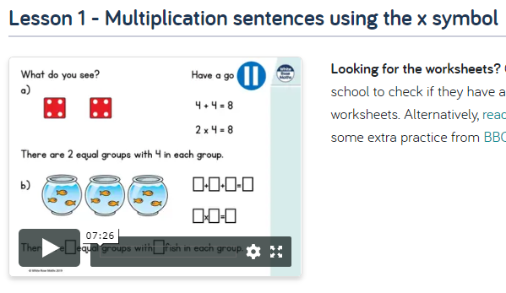 | TT Rockstars  Use your login details.  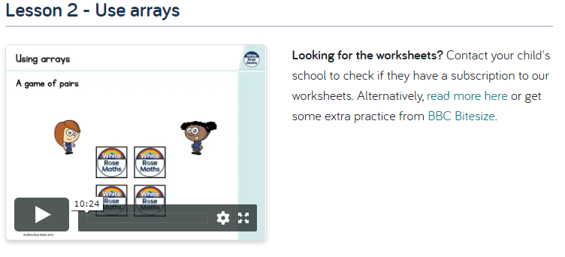 | Maths  https://whiterosemaths.com/homelearning/year-2/  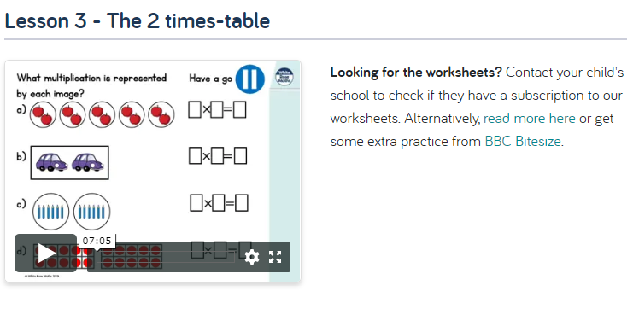 | TT Rockstars  Use your login details.  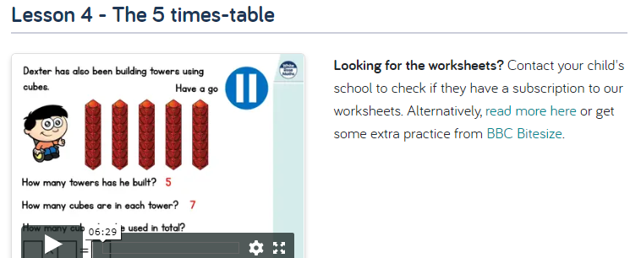 | Maths  https://whiterosemaths.com/homelearning/year-2/  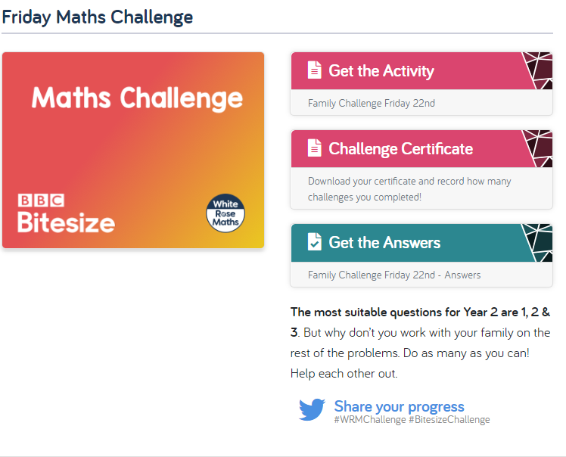
10am | Break – get some fresh air | Break – get some fresh air | Break – get some fresh air | Break – get some fresh air | Break – get some fresh air
10.20am | Bug Club | Bug Club | Bug Club | Bug Club | Bug Club
10.50am | English  Practise your letter formation  t  https://www.talk4writing.co m/wpcontent/uploads/2020/06/Y 2-Superheroes-1.pdf  Page 9-11  Creative challenge. Create your own superhero, follow the instructions. | English  Practise your letter formation  u  Page 12-13  Make your superhero.  https://www.talk4writing.co m/wpcontent/uploads/2020/06/Y 2-Superheroes-1.pdf | English  Practise your letter formation v  Page 14  Complete the descriptive writing.  https://www.talk4writing.co m/wpcontent/uploads/2020/06/Y 2-Superheroes-1.pdf | English  Practise your letter formation w  Page 16  Complete the activities.  https://www.talk4writing.co m/wpcontent/uploads/2020/06/Y 2-Superheroes-1.pdf | English  Practise your letter formation x  Page 17-18  Complete the superhero rescue challenge.  https://www.talk4writing.co m/wpcontent/uploads/2020/06/Y 2-Superheroes-1.pdf
11.30am | Lunch | Lunch | Lunch | Lunch | Lunch
12.30pm | Read your school book or a book of your choice.  https://www.oxfordowl.co.uk/for-home/reading/ | Read your school book or a book of your choice.  https://www.oxfordowl.co.uk/for-home/reading/ | Read your school book or a book of your choice.  https://www.oxfordowl.co.uk/for-home/reading/ | Read your school book or a book of your choice.  https://www.oxfordowl.co.uk/for-home/reading/ | Read your school book or a book of your choice.  https://www.oxfordowl.co.uk/for-home/reading/
12.50pm | Go Noodle- Banana, Banana, Meatball  hhttps://www.youtube.com/watch?v=BQ9q4U2P3ig&t=8s | Joe Wicks workout  https://www.youtube.com/watch?v=EXt2jLRlaf8 | Go Noodle- Baby shark  https://www.youtube.com/watch?v=2ERLMzBk3Qk | Joe Wicks workout  https://www.youtube.com/watch?v=d3LPrhI0v-w | Cosmic Yoga- Dance party  https://www.youtube.com/watch?v=23VdtT0vQUY&t=35s
1.20pm | Virtual Trip.  Ask your grownups!  This week we are trying something different. Below there is a link to our website, where you can take a trip to lots of different places, using the internet. Click on the link below,  http://www.rydersgreenprimary.co.uk/info-for-parents/virtual-trips/  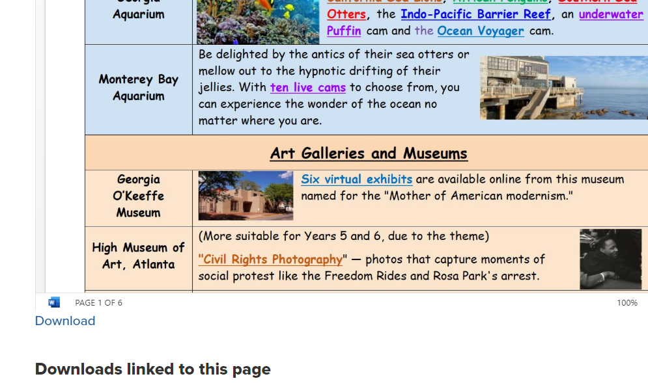  Then you will need to click the link on this page. This will open up a word document. Choose a trip to go on. Here is an example- Barcelona’s football stadium. Click the link and have a look.  https://www.youvisit.com/tour/campnou | Virtual Trip  Our recommended trip for today is to outer space! See all the planets and our solar system.  https://nineplanets.org/tour/  Now why not take a trip to look at rockets and shuttles:  https://www.youtube.com/watch?v=9Qe5RqyMNhc | Virtual Trip  Have another look at the trips page. http://www.rydersgreenprimary.co.uk/info-for-parents/virtual-trips/  Choose a trip you would like to go on and enjoy.  Alternatively, Miss Ebanks and Miss Kaur loved seeing the sharks at the aquarium. Have a look https://www.montereybayaquarium.org/animals/live-cams/shark-cam | Virtual Trip  Your choice  http://www.rydersgreenprimary.co.uk/info-for-parents/virtual-trips/  We recommend you trying- African Dancing:  http://www.rydersgreenprimary.co.uk/info-for-parents/virtual-trips/ | Virtual Trip  Go to London and have a look inside Buckingham Palace  https://www.royal.uk/virtual-tours-buckingham-palace  Can you draw the palace or something you have seen inside it? Miss Ebanks & Miss Kaur would love to see your drawings.
2. 45pm | Reading slot  Class reader / Bug Club | Reading slot  Class reader / Bug Club | Reading slot  Class reader / Bug Club | Reading slot  Class reader / Bug Club | Reading slot  Class reader / Bug Club
3.15pm

Your year group teachers will be available to reply to emails between 9am and 3pm Monday – Friday. During this time, they will be working on other school priorities as well, so you may not get an emailed reply straight away.

Mrs Trapani luisa.trapani@rydersgreen.sandwell.sch.uk  Miss Kaur sanjeet.kaur@rydersgreen.sandwell.sch.uk  Miss Ebanks kelly.ebanks@rydersgreen.sandwell.sch.uk | Mrs Robinson lisa.robinson@rydersgreen.sandwell.sch.uk  Mrs leech gwen.leech@ydersgreen.sandwell.sch.uk

