Year 2 weekly timetable : Monday 1st June 2020
Time | Monday | Tuesday | Wednesday | Thursday | Friday
Before 9am | Morning routine  Get ready for your day! | Morning routine  Get ready for your day! | Morning routine  Get ready for your day! | Morning routine  Get ready for your day! | Morning routine  Get ready for your day!
9am | Go noodle  https://www.youtube.com/watch?v=KM-59ljA4Bs | Joe Wicks workout  https://www.youtube.com/watch?v=d3LPrhI0v-w | Go noodle  https://www.youtube.com/watch?v=vMSAzl6V95M | Joe Wicks workout  https://www.youtube.com/watch?v=EXt2jLRlaf8 | Go noodle  https://www.youtube.com/watch?v=wPCGfa44bF0
9.20am | Maths  https://kids.classroomsecrets.co.uk/category/year-2/video-tutorials-year-2-maths/page/4/  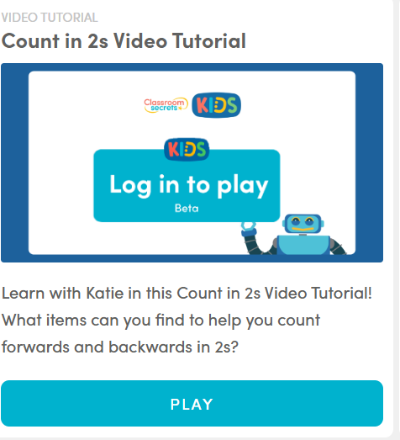 | TT Rockstars  Use your login details.  Maths: https://kids.classroomsecrets.co.uk/category/year-2/video-tutorials-year-2-maths/page/4/  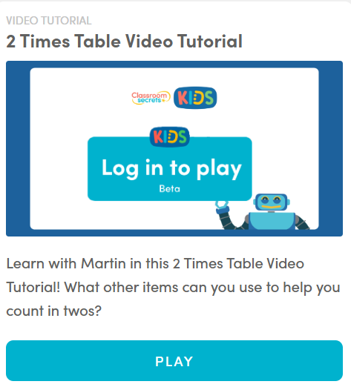 | Maths  Practise forming your numbers. 0-9  https://kids.classroomsecrets.co.uk/category/year-2/video-tutorials-year-2-maths/page/3/  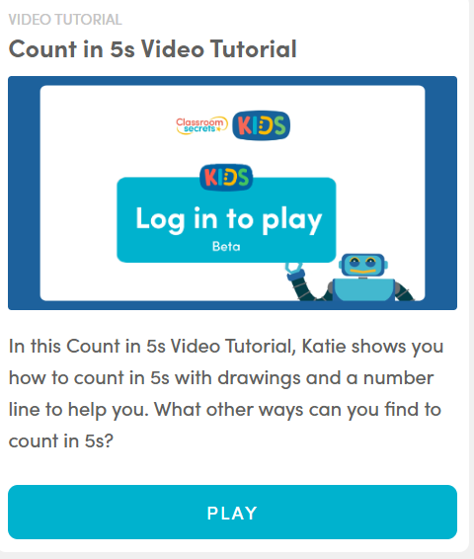 | TT Rockstars  Use your login details.  Maths:  https://kids.classroomsecrets.co.uk/category/year-2/video-tutorials-year-2-maths/page/2/  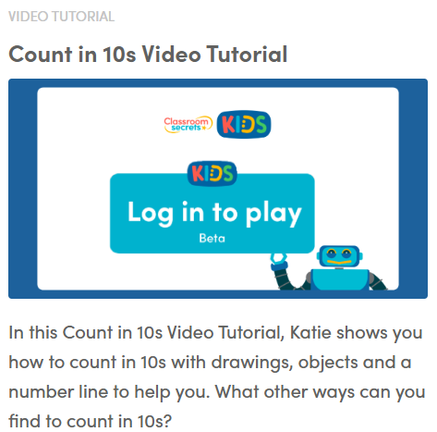 | Maths  Practise forming your numbers. 0-9  1 page of your Maths booklet  Maths  https://kids.classroomsecrets.co.uk/category/year-2/video-tutorials-year-2-maths/  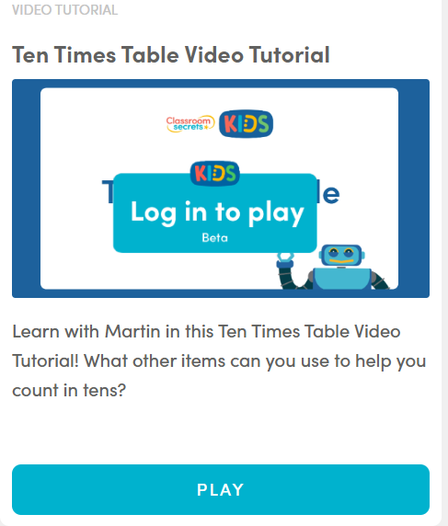
10am | Break – get some fresh air | Break – get some fresh air | Break – get some fresh air | Break – get some fresh air | Break – get some fresh air
10.20am | Bug Club | Spelling Shed- Play some of our games.  https://www.spellingshed.com/en-gb | Bug Club | Spelling Shed- Play some of our games.  https://www.spellingshed.com/en-gb | Bug Club
10.50am | English  Practise your letter formation  Z  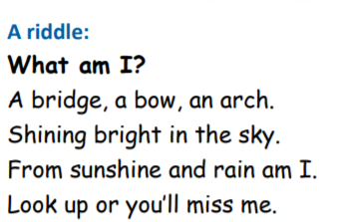From this riddle, can you guess what we are doing this week?  -------------------------  This week you are starting a non-fiction text. The first few pages tell you and your grown up’s a little bit of information about them first and what is expected of you in this work.  Our learning starts on page 4- page 7. Here you will write down what you know about Rainbows and what you have learnt. There is even a link to listen to some more information.  https://www.talk4writing.com/wp-content/uploads/2020/05/Y2-Rainbows.pdf | English  Practise your letter formation  a  Today you are recapping the information you learnt yesterday on Rainbows. You will find todays activity on page 8.  Can you find out any more fascinating facts? Feel free to email us and let us know too!  https://www.talk4writing.com/wp-content/uploads/2020/05/Y2-Rainbows.pdf | English  Practise your letter formation  b  Today you will be learning what an Explanation text is and will even be finding some of the features. Have fun! Today’s lesson is on page 9. Page 10 shows you how you could present your work.  https://www.talk4writing.com/wp-content/uploads/2020/05/Y2-Rainbows.pdf | English  Practise your letter formation  c  Today you are completing pages 11 and 12, planning your own explanation text!  https://www.talk4writing.com/wp-content/uploads/2020/05/Y2-Rainbows.pdf | English  Practise your letter formation  d  Today you will be using your plan (that you created following pages 11 and 12) to write your explanation text. Use page 13 as your success criteria. Make sure this is your neatest handwriting and that they make sense, so check and check again. We would love to see them!  https://www.talk4writing.com/wp-content/uploads/2020/05/Y2-Rainbows.pdf  Link to a Thesaurus for synonyms  https://www.collinsdictionary.com/dictionary/english-thesaurus
11.30am | Lunch | Lunch | Lunch | Lunch | Lunch
12.30pm | Read your school book or a book of your choice.  https://www.oxfordowl.co.uk/for-home/reading/ | Read your school book or a book of your choice.  https://www.oxfordowl.co.uk/for-home/reading/ | Read your school book or a book of your choice.  https://www.oxfordowl.co.uk/for-home/reading/ | Read your school book or a book of your choice.  https://www.oxfordowl.co.uk/for-home/reading/ | Read your school book or a book of your choice.  https://www.oxfordowl.co.uk/for-home/reading/
12.50pm | PE with Joe Wicks  https://www.youtube.com/watch?v=EXt2jLRlaf8&t=15s | Cosmic Yoga- Disco  https://www.youtube.com/watch?v=23VdtT0vQUY | PE with Joe Wicks  https://www.youtube.com/watch?v=hvJXQT4gowg | Kidz Bop Kidz- Can’t stop the feeling  https://www.youtube.com/watch?v=Ojblhvzvjsk | Cosmic Yoga- Saturday morning yoga  (You could do this again on Saturday!)  https://www.youtube.com/watch?v=inyw6mM4xTU
1.20pm | Draw a picture, with a beautiful rainbow in the background.  If you are super impressed with it (you should be) email us a picture of it. | Draw and label a diagram of how rainbows are formed, use all of the new vocabulary you have learnt! | Creative activity – Sketch with Rob- Wilbur  https://www.youtube.com/watch?v=278alxmnGCM | Creative activity- Sketch with Rob- a monster!  https://www.youtube.com/watch?v=PedfXGus_K0 | Creative activity –Draw images and a diagram to complete your explanation text. Remember your picture should have a caption!
2. 45pm | Reading slot  Class reader / Bug Club | Reading slot  Class reader / Bug Club | Reading slot  Class reader / Bug Club | Reading slot  Class reader / Bug Club | Reading slot  Class reader / Bug Club
3.15pm

Your year group teachers will be available to reply to emails between 9am and 3pm Monday – Friday. During this time, they will be working on other school priorities as well, so you may not get an emailed reply straight away.

Mrs Trapani luisa.trapani@rydersgreen.sandwell.sch.uk  Miss kaur sanjeet.kaur@rydersgreen.sandwell.sch.uk  Miss Ebanks kelly.ebanks@rydersgreen.sandwell.sch.uk | Mrs Robinson lisa.robinson@rydersgreen.sandwell.sch.uk  Mrs leech gwen.leech@ydersgreen.sandwell.sch.uk

