Year 6 weekly timetable - Monday 25th May 2020
Time | Monday 29th June | Tuesday 30th June | Wednesday 1st July | Thursday 2nd July | Friday 3rd July
Before 9am | Morning routine | Morning routine | Morning routine | Morning routine | Morning routine
9am | Joe Wicks workout  https://www.youtube.com/watch?v=d3LPrhI0v-w | Joe Wicks workout  https://www.youtube.com/watch?v=EXt2jLRlaf8 | Joe Wicks workout  https://www.youtube.com/watch?v=5MBEyQIlrfo | Joe Wicks workout  https://www.youtube.com/watch?v=d3LPrhI0v-w | Joe Wicks workout  https://www.youtube.com/watch?v=EXt2jLRlaf8
9.30am | English  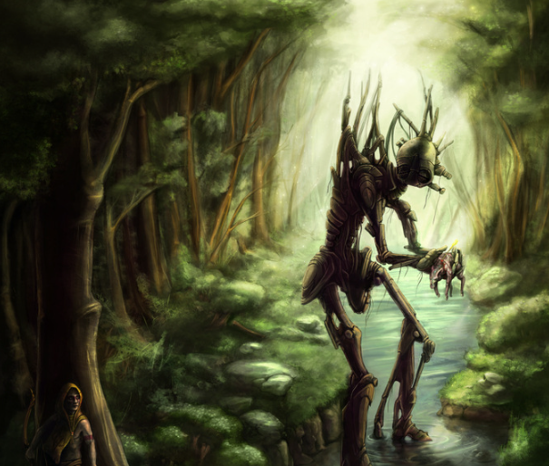  Use the above image to write a short story  Task 1 – plan your initial ideas, brainstorm your thoughts, adjectives and story plot  Task 2 – write your short story (no more than 1 page of A4)  Task 3 – up-level and write final draft – this can be done on word or hand written. | English  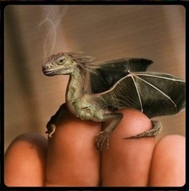  Questions for discussion:  Where is it from?  Why is it so small?  Are there more like him?  Where does he live?  How will you look after it?  Will you keep it a secret or tell someone?  What is it called?  Is it magic? What magic can it do?  Come up with your own inference questions for the image – this will support your story writing for tomorrow. | English  Use the image from yesterday – go back over the questions you answered and the inference questions you considered.  Following the same format as Monday use the image from yesterday to create a short story.  Task 1 – plan your initial ideas, brainstorm your thoughts, adjectives and story plot  Task 2 – write your short story (no more than 1 page of A4)  Task 3 – up-level and write final draft – this can be done on word or hand written. | English  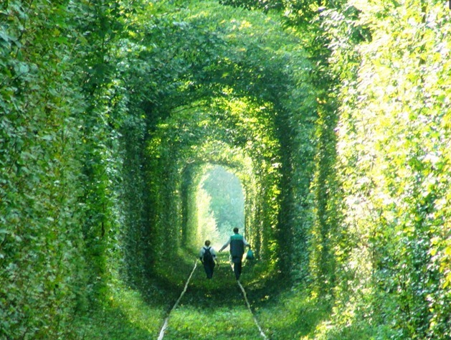  Task 1 – using the image above mind map adjectives and inferences/questions it raises  Task 2 – write a setting description to support the above image  Task 3 – up-level as and where appropriate and write up final piece. | English  Children to come up with and draw their own image similar to the ones that have been worked on this week. Create some of your own questions to ask your audience/readers and consider the inferences it raises  Draw your picture and write your questions underneath it.
10.15am | Break – get some fresh air | Break – get some fresh air | Break – get some fresh air | Break – get some fresh air | Break – get some fresh air
10.30am | Bug Club | Bug Club | Bug Club | Bug Club | Bug Club
10.45am  11.45am | Maths  Project lesson – building a theme park (print off budget sheet and price sheet for each child)  Go through theme park powerpoint, this will outline the skills being taught throughout the week and outline the lesson tasks and prices that the children will need to stick to. Children can use a post it note or their books to make notes during the presentation to refer back to during the activities.  Use the pricing sheet as support  Children to complete their own budget sheet to work out costs and budget what they can have and would like at their park.  Children should write a reflection towards the end of the lesson to discuss what they found easy to solve, difficult and what they did to resolve it. | Maths  Project lesson – Designing your brochure to advertise your theme park  Go through the powerpoint presentation for lesson two.  Children can research brochures for theme park attractions – what makes people want to pick it up? Read it? Or even attend? Think of what is needed to make your brochure exciting and engaging.  Children to design their own brochure ensuring all relevant information is included - this does not need to include cost at this point it is more about exciting visitors that a new park is being advertised | Maths  Project lesson – running costs  Go through the powerpoint presentation lesson 3to consider how much the running costs of the park is going to be.  Children to complete the costing sheet and consider the following questions:  How much will it cost to run?  How much you may need to charge for tickets to ensure you make a profit?  How much profit could you make?  You need to include your calculations and explanations to support these calculations to ensure it is clear what the calculations are for, what it means for you and the conclusions you have drawn. | Maths  Project lesson – running costs finalised  Powerpoint lesson 4  Continue working through running costs. Children should use today’s lesson to finalise their costings and make a final decision on how much tickets will be for entrance to their theme park – this can be presented individually to the rest of the class.  Children can discuss why they have chosen to charge this much for the tickets and why, including mathematical calculations. | Maths  Project lesson - using the grid from the beginning of the week – outline how the theme park is going to be set out – where are things going to be positioned – this needs to be completed on maths squared paper – it can be colour coded. Go back to the first presentation slide to look at how big each item is and how it can fit. Remember there needs to be a one square gap perimeter from each feature and there also needs to be so many seating facilities as well as bins etc
11.45-12pm | ERIC | ERIC | ERIC | ERIC | ERIC
12pm-12.30pm | SPaG  Century Tech | SPaG  Century Tech | SPaG  Century Tech | SPaG  Century Tech | SPaG  Century Tech
1.30pm-2.30pm | History/ICT  Creation of a powerpoint presentation  Children to research a chosen history topic that they are personally interested in.  Children to then create their own powerpoint presentation with information, images and facts on this topic. | History/ICT  Children to continue with their powerpoint presentation and send their completed project to their class teacher | PE  Get yourself into the garden, you could either complete the following  - Make your own circuit, a range of races or drills  - Complete a task such as skipping or playing football etc  - If you have a trampoline building your skills of balance and control  - Ball skills – throwing, catching etc | PSHE  Phone and online safety  Please take a look at each of the scenarios given – what should you do in each of these scenarios and why?  This can either be completed in your topic books or written up on a word document and emailed to your class teacher,  Please email your class teacher if you are unsure of something | ART  https://www.bbc.co.uk/bitesize/clips/zdsb9j6  Use the link to watch how to create a landscape drawing  Choose one of your own, this can be a drawing from somewhere you may be visiting or an image of a landmark you find interesting.  It Is your choice
2.30pm-3pm | Creative activity –  http://www.robbiddulph.com/draw-with-rob | Creative activity –  http://www.robbiddulph.com/draw-with-rob | Creative activity –  http://www.robbiddulph.com/draw-with-rob | Creative activity –  http://www.robbiddulph.com/draw-with-rob | Creative activity –  http://www.robbiddulph.com/draw-with-rob
3p;m-3.15pm | Newsround  https://www.bbc.co.uk/newsround/news/watch_newsround  Send an email to your class teacher with your opinion of the news of the day. | Newsround  https://www.bbc.co.uk/newsround/news/watch_newsround  Send an email to your class teacher with your opinion of the news of the day. | Newsround  https://www.bbc.co.uk/newsround/news/watch_newsround  Send an email to your class teacher with your opinion of the news of the day. | Newsround  https://www.bbc.co.uk/newsround/news/watch_newsround  Send an email to your class teacher with your opinion of the news of the day. | Newsround  https://www.bbc.co.uk/newsround/news/watch_newsround  Send an email to your class teacher with your opinion of the news of the day.
3.15pm | End of school day – don’t forget that you should still read your home reader to your parents/ carers | End of school day – don’t forget that you should still read your home reader to your parents/ carers | End of school day – don’t forget that you should still read your home reader to your parents/ carers | End of school day – don’t forget that you should still read your home reader to your parents/ carers | End of school day – don’t forget that you should still read your home reader to your parents/ carers

Your year group teachers will be available to reply to emails between 9am and 3.30pm Monday – Friday. During this time, they will be working on other school priorities as well, so you may not get an emailed reply straight away. Any emails after 3.30pm will be replied to the following morning and if emails are received over the weekend you will receive a reply on Monday morning.

Miss Adams rebecca.adams@rydersgreen.sandwell.sch.uk  Miss Allen rebecca.allen@rydersgreen.sandwell.sch.uk | Miss Randle samantha.randle@rydersgreen.sandwell.sch.uk  Miss Garrington faye.garrington@rydersgreen.sandwell.sch.uk  Any technical support you may require or if you are having any problems with your logins please contact:  Miss Johal angela.johal@rydersgreen.sandwell.sch.uk

