Year 3 weekly timetable – Monday 13th July 2020
Time | Monday | Tuesday | Wednesday | Thursday | Friday
Before 9am | Morning routine | Morning routine | Morning routine | Morning routine | Morning routine
9am | Joe Wicks P.E lesson  https://www.youtube.com/channel/UCAxW1XT0iEJo0TYlRfn6rYQ | Joe Wicks P.E lesson  https://www.youtube.com/channel/UCAxW1XT0iEJo0TYlRfn6rYQ | Joe Wicks P.E lesson  https://www.youtube.com/channel/UCAxW1XT0iEJo0TYlRfn6rYQ | Joe Wicks P.E lesson  https://www.youtube.com/channel/UCAxW1XT0iEJo0TYlRfn6rYQ | Joe Wicks P.E lesson  https://www.youtube.com/channel/UCAxW1XT0iEJo0TYlRfn6rYQ
9.30am | Maths –  To describe the part whole relationship.  https://classroom.thenational.academy/lessons/to-describe-the-part-whole-relationship | Maths –  To recognise parts that are equal and parts that are unequal.  https://classroom.thenational.academy/lessons/to-recognise-parts-that-are-equal-and-parts-that-are-unequal | Maths –  To recognise identify and describe unit fractions.  https://classroom.thenational.academy/lessons/to-recognise-identify-and-describe-unit-fractions | Maths –  To find unit fractions of a given quantity.  https://classroom.thenational.academy/lessons/to-find-unit-fractions-of-a-given-quantity | Maths –  To describe unit and non-unit fractions.  https://classroom.thenational.academy/lessons/to-describe-unit-and-non-unit-fractions
10:20am | Break – get some fresh air | Break – get some fresh air | Break – get some fresh air | Break – get some fresh air | Break – get some fresh air
10.35am | Bug Club | Bug Club | Bug Club | Bug Club | Bug Club
10.50am | English –  Reading comprehension.  https://classroom.thenational.academy/lessons/reading-comprehension | English –  Reading comprehension- part 2.  https://classroom.thenational.academy/lessons/reading-comprehension-5f6674 | English –  Reading the example and identify the key features.  https://classroom.thenational.academy/lessons/read-the-example-and-identify-the-key-features | English –  Key features: SPaG focus.  https://classroom.thenational.academy/lessons/key-feature-spag-focus | English –  To use key features in order to write own composition.  https://classroom.thenational.academy/lessons/to-use-key-features-in-order-to-write-own-composition-2042b6
12.00pm | Lunch | Lunch | Lunch | Lunch | Lunch
1.00pm | TT RockStars | Spelling Shed | TT RockStars | Spelling Shed | TT RockStars
1:15pm | Mindfulness activity-  5 things you can see.  4 things you can touch.  3 things you can hear.  2 things you can smell.  1 thing you can taste. | Debate-  Should we have robots? Explain why. | Mindfulness activity-  What does mindfulness mean to you?  List the different types of ways you are mindful. | Debate-  Animal testing should be banned. Explain why. | Mindfulness activity-  Write a poem about why you are proud of yourself.
1.35pm | Wellbeing activity-  Dance away…  Play your favourite songs and dance. Take some time out and put on your dancing shoes!! | Wellbeing activity-  Play a sport with your family. Get everyone involved. | Wellbeing activity-  Begin to learn to play a new instrument.  Find out new information you do not know about that piece of instrument. | Wellbeing activity-  Have a family quiz. Take turns setting the questions. Work in your teams and ask and answer questions about countries, food, music etc. | Wellbeing activity-  Carry research out about learning some facts about a new culture. A culture you don’t have much knowledge about.
2.00pm | Art/DT activity-  Choose your favourite book and draw your favourite character. How will you add colour? You could use paint, pencils, pens, collage, it is up to you! | Art/DT activity-  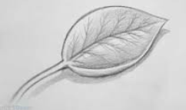  Go outside and draw something you can see. You might want to draw a scene, you might want to find something small and draw it larger so you can use a range of tones. | Art/DT activity-  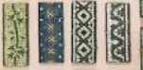  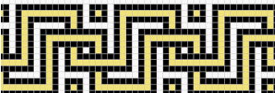  Research Roman patterns and mosaics and create a page of facts and examples. | Art/DT activity-  Draw your favourite place in the UK and use colour to make it stand out.  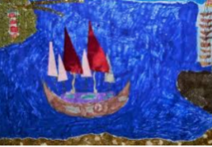 | Art/DT activity-  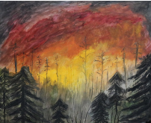  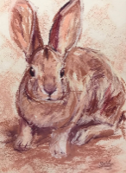  Find out more about Stephanie Peters and create a piece of her work. https://www.stephartist.com/
3.15pm | End of school day – don’t forget that you should still read your home reader to your parents/ carers | End of school day – don’t forget that you should still read your home reader to your parents/ carers | End of school day – don’t forget that you should still read your home reader to your parents/ carers | End of school day – don’t forget that you should still read your home reader to your parents/ carers | End of school day – don’t forget that you should still read your home reader to your parents/ carers

Your year group teachers will be available to reply to emails but as it is the Easter holidays, these responses might not be as quick as usual.

Miss Houldey jordan.houldey@rydersgreen.sandwell.sch.uk  Miss Fiaz samia.fiaz @rydersgreen.sandwell.sch.uk | Miss Kaur pam.kaur@rydersgreen.sandwell.sch.uk  Miss Ellis debbie.ellis@rydersgreen.sandwell.sch.uk  Mrs Stott pat.stott@rydersgreen.sandwell.sch.uk

