Information for Parents – devise Safe Guarding – Keep your children safe !

Information from the official PEGI website.
Essentially, the PEGI rating on a game confirms that it contains content suitable for a certain age group and above. So a 7-rated game is suitable for everyone who is seven or older, while an 18-rated game is deemed suitable for adults only.

PEGI games ratings explained

PEGI 3
The majority of games in this category do not contain anything that requires rating or warrants a content warning. Games given this rating are considered suitable for all age groups.

Some violence in a comical context or child-friendly setting is acceptable, as is nudity when shown in a completely natural and non-sexual manner such as breast feeding. PEGI 3
The content of games with a PEGI 3 rating is considered suitable for all age groups. The game should not contain any sounds or pictures that are likely to frighten young children. A very mild form of violence (in a comical context or a childlike setting) is acceptable. No bad language should be heard.

PEGI 7
Any game that would normally be rated at 3 but contains some possibly frightening scenes or sounds may be considered suitable in this category.
A little more violence is permissible at PEGI 7. It is always unrealistic and often directed towards fantasy characters, though very mild non-realistic violence to humans may also feature. Implied violence (for example the bombing of a city where violence is not seen directly) is also dealt with at this level.
Game content with scenes or sounds that can possibly frightening to younger children should fall in this category. Very mild forms of violence (implied, non-detailed, or non-realistic violence) are acceptable for a game with a PEGI 7 rating.

PEGI 12
At a PEGI 12 level more graphic and realistic looking violence towards fantasy characters is allowed. Any violence towards human characters must look unrealistic unless it consists of only minor or trivial injury such as a slap.
Sexual posturing of the type often seen in music videos is also allowed at this level as is sexual innuendo.
Some bad language is allowed but it can be no more than mild swearing.
PEGI 12 is the minimum rating a game which teaches or encourages gambling can receive, though the descriptor also appears on PEGI 16 and PEGI 18 games.
A game at this level may feature horror content such as strong threat and dread or graphic injury details.
Video games that show violence of a slightly more graphic nature towards fantasy characters or non-realistic violence towards human-like characters would fall in this age category. Sexual innuendo or sexual posturing can be present, while any bad language in this category must be mild. Gambling as it is normally carried out in real life in casinos or gambling halls can also be present (e.g. card games that in real life would be played for money).

PEGI 16
At the 16 level you can expect to see more mature and realistic violence against human characters. The game may deal heavily with death and injury to humans. Gory and bloody violence may be included at a PEGI 16 level but only if the game is arcade style.
Sexual activity can be shown but it must not include visible genitals. Depictions of erotic nudity may feature.
The worst forms of bad language can be heard and will often include sexual expletives.
The use of tobacco and alcohol may be encouraged, and the game can feature the use of illegal drugs. The game could glamorise crime.
This rating is applied once the depiction of violence (or sexual activity) reaches a stage that looks the same as would be expected in real life. The use of bad language in games with a PEGI 16 rating can be more extreme, while games of chance, and the use of tobacco, alcohol or illegal drugs can also be present.

PEGI 18
The adult classification is applied when the level of violence becomes gross. Gross violence is classed as horrific methods of bringing death or severe injury, including torture, decapitation or dismemberment.
Violence against vulnerable characters such as children and the elderly may feature, along with motiveless violence against multiple innocents. Sexual violence and threat are also classified at PEGI 18.
The game may include detailed descriptions of criminal techniques, or it may glamorise the use of illegal drugs.
Sexual activity with visible genital organs can be shown.
The adult classification is applied when the level of violence reaches a stage where it becomes a depiction of gross violence, apparently motiveless killing, or violence towards defenceless characters. The glamorisation of the use of illegal drugs and explicit sexual activity should also fall into this age category.

Content labels
As well as the age rating, there are content labels, or descriptors, to explain why the game was given its rating. These are displayed on the packaging of the game (see image at the top of the page). As well as those pictured, there is one of Discrimination but it has never appeared on a game box in the UK. If a game did include discrimination, it is likely that it would infringe national criminal law.

THE PEGI CONTENT DESCRIPTORS
The game contains depictions of violence. In games rated PEGI 7 this can only be non-realistic or non-detailed violence. Games rated PEGI 12 can include violence in a fantasy environment or non-realistic violence towards human-like characters, whereas games rated PEGI 16 or 18 have increasingly more realistic-looking violence.​
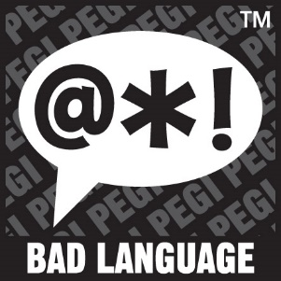
The game contains bad language. This descriptor can be found on games with a PEGI 12 (mild swearing), PEGI 16 (e.g. sexual expletives or blasphemy) or PEGI 18 rating (e.g. sexual expletives or blasphemy).

This descriptor may appear on games with a PEGI 7 if it contains pictures or sounds that may be frightening or scary to young children, or on PEGI 12 games with horrific sounds or horror effects (but without any violent content).
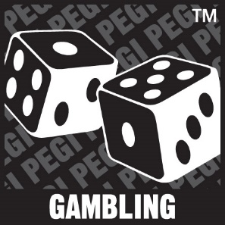
The game contains elements that encourage or teach gambling. These simulations of gambling refer to games of chance that are normally carried out in casinos or gambling halls. Games with this sort of content are PEGI 12, PEGI 16 or PEGI 18.
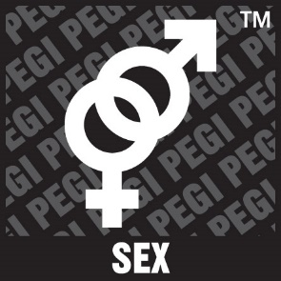

This content descriptor can accompany a PEGI 12 rating if the game includes sexual posturing or innuendo, a PEGI 16 rating if there is erotic nudity or sexual intercourse without visible genitals or a PEGI 18 rating if there is explicit sexual activity in the game. Depictions of nudity in a non-sexual content do not require a specific age rating, and this descriptor would not be necessary.

The game refers to or depicts the use of illegal drugs, alcohol or tobacco. Games with this content descriptor are always PEGI 16 or PEGI 18.

The game contains depictions of ethnic, religious, nationalistic or other stereotypes likely to encourage hatred. This content is always restricted to a PEGI 18 rating (and likely to infringe national criminal laws).

