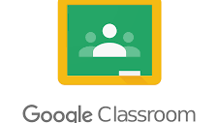

Google Classroom Student Guide

Logging in
- Go to https://classroom.google.com and click on the ‘Sign in’ button.
- Having got to Google Classroom, to sign in, students must enter their school email login credentials. This is their school email address and their password.
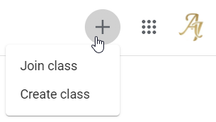
- To join a class, please copy the code your class teacher has sent you by email or text and click on ‘Join Class’.

- 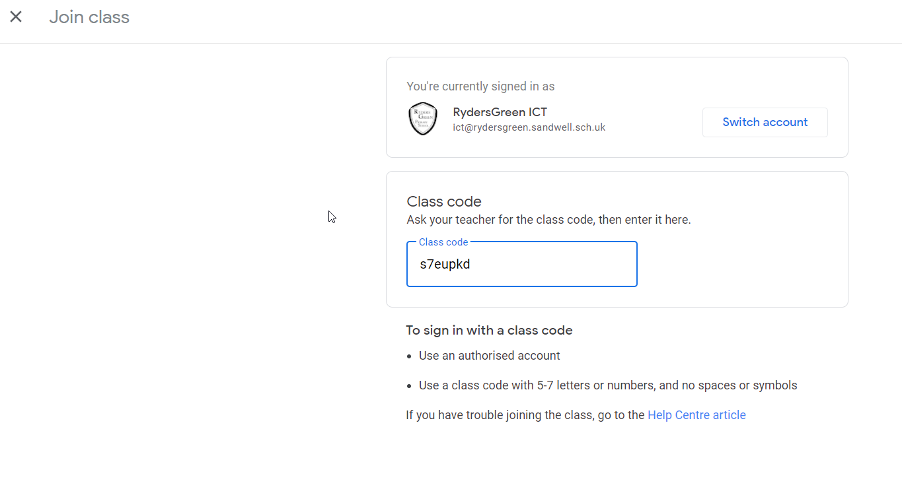

- Having logged in, students will be presented with all of the Classrooms that they have already enrolled onto.
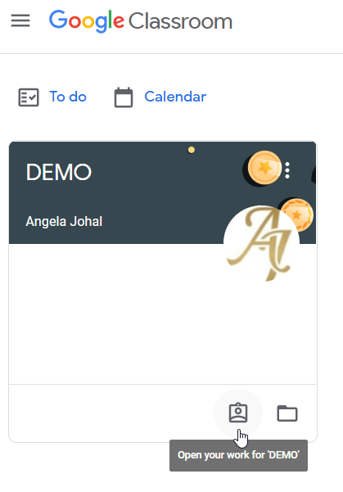
For a student to enrol onto another Classroom, they must click on the "+" sign at the top of the screen, followed by "Join Class" and enter the new class code.

- After clicking on "Join Class", students must then type in the code that was provided by their teacher. Note: They only need to do this once. After they have joined the class once, they will remain as a member of the Classroom for the rest of the academic year.

Viewing and Accessing Classwork
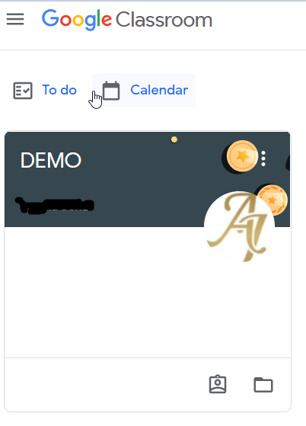
- To view homework or tasks set, - once logged in to Google Classroom - you need to click on the class that you wish to view.

- Having clicked on your classroom, you will now be in a Google Classroom.
Here, they will have 3 tabs in front of them; “Stream”, “Classwork” and “People”.
If your teacher has set you some work, you will see this posted as below.
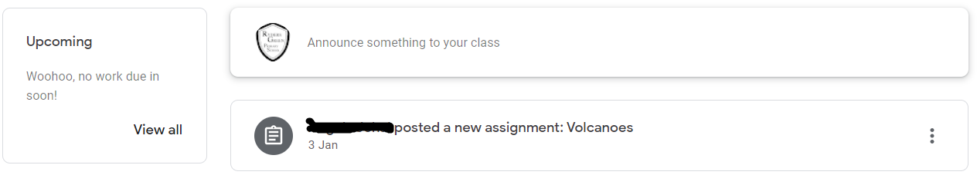

The “Stream” Page
When the teacher posts an assignment on their Google Classroom, it will contain the name of the task, a description of what the student has to do and possibly attached resources where possible. It will also have a due date for when the assignment/task needs to be completed by.

You will be told by

Your teacher on whether you need to complete the task online in Google Classroom or offline in another way.
When you click on the assignment/task your teacher has created, you will see a screen similar to this.
You will have the task to complete and any resources your teacher has uploaded to help with the work/topic area.
‘Class Comment’ - allows you to add a comment to interact with your teacher and the rest of your class.
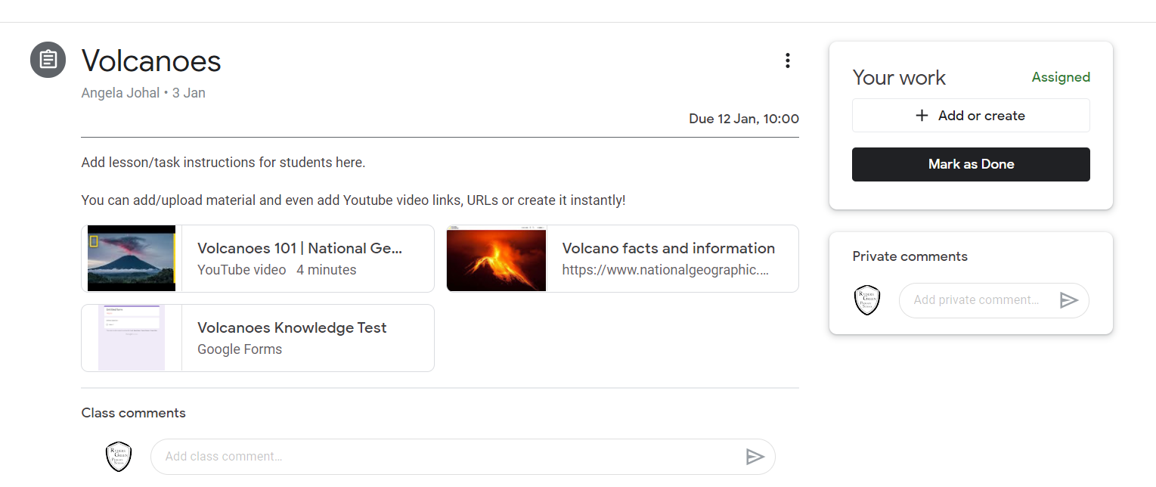

If you need to message your teacher privately about the work then you can do so as shown below.
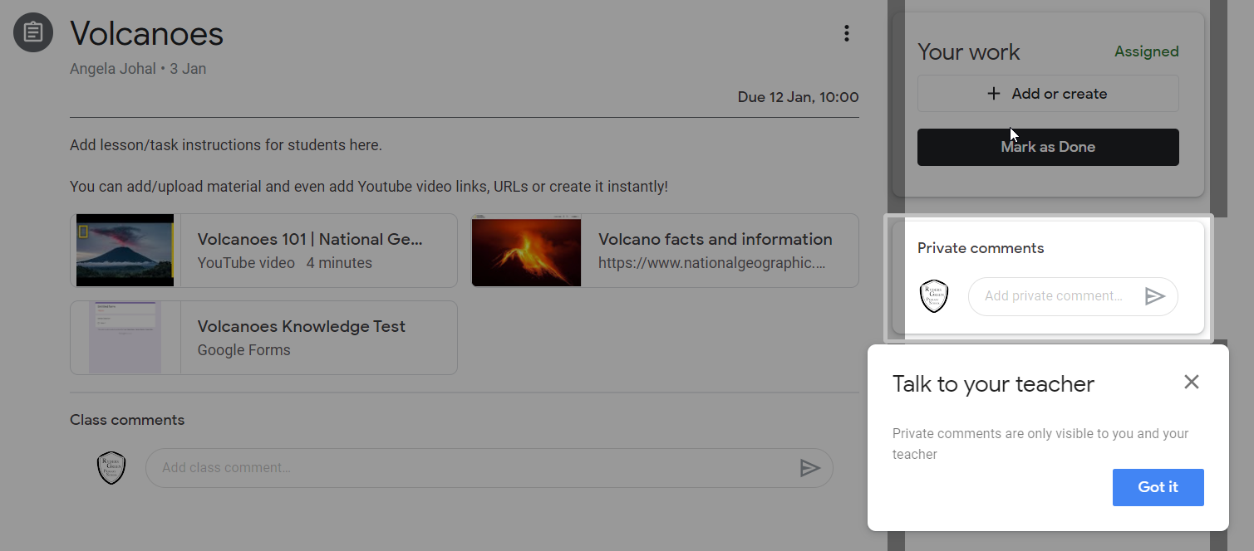

Classwork Page
Click on the ‘Classwork’ option to view all work assigned to you by your teacher.
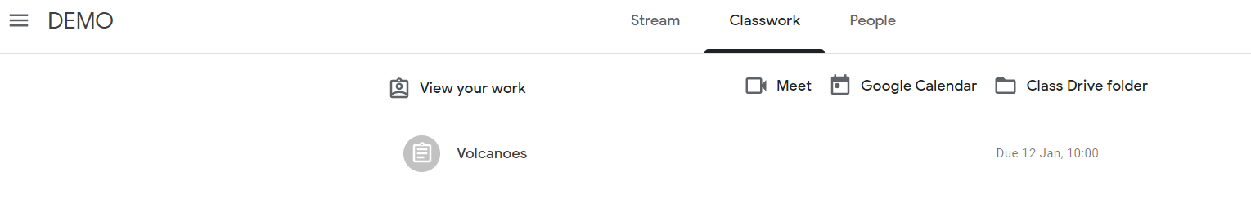
If you click on ‘View Work’ this will list all your tasks.

Completing & Submitting Work
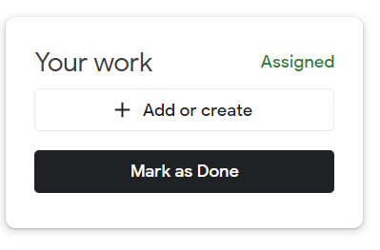
When you have completed the task,
click on ‘Mark as done’.

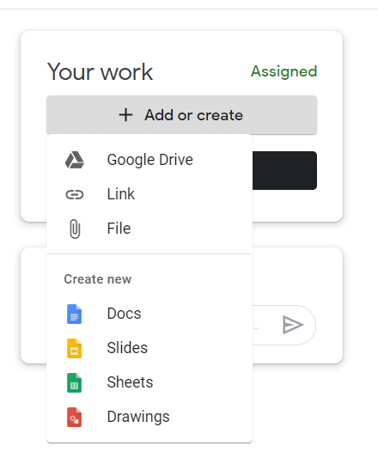
If you need to ‘add or create’ a document online to
complete your work, you can use ‘Docs/Slides/Sheets’
(this is similar to Microsoft Word/Excel/Powerpoint)
or upload a file from their computer or their online storage Google Drive.

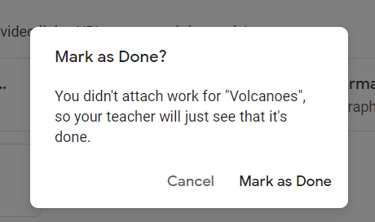
If you do not attach anything but have completed the work with your teacher, you will see this message.
Click on ‘Mark as Done’ or ‘Cancel’
and upload your work.

When you have completed your work, your teacher will be notified and he/she can then see who has handed in their work.
