Year 1 Weekly Timetable – w/b 04.01.21 (week 1)
Time | Monday | Tuesday | Wednesday | Thursday | Friday
Before 9am | Teacher training day. | Morning routine  Get ready for your day! | Morning routine  Get ready for your day! | Morning routine  Get ready for your day! | Morning routine  Get ready for your day!
9am |  | Jack Hartman – Let’s get fit – count to 120.  https://www.youtube.com/watch?v=MA9BhxGwGMs  Then  Write down the 5 times tables:  e.g. 1 x 5 = 5  (Please use the ‘five times tables help sheet’ to help you)  file:///F:/2020%202021/Corona%20WFH%202021/Timetables/Week%201%20-%20wc%2004.1.21/Five%20times%20table%20help%20sheet.pdf | Number Jacks – 2 times tables practice.  https://www.youtube.com/watch?v=3yf3xgE8wMc  Then  Jack Hartman – Let’s get fit – count to 120.  https://www.youtube.com/watch?v=MA9BhxGwGMs | Jack Hartman – Let’s get fit – count by 1’s to 150.  https://www.youtube.com/watch?v=4htW_ZIZoFk  Then  Write down the 2 times tables:  e.g. 1 x2 = 2  (Please use the ‘two times tables help sheet’ to help you)  file:///F:/2020%202021/Corona%20WFH%202021/Timetables/Week%201%20-%20wc%2004.1.21/Two%20times%20table%20help%20sheet.pdf | Jack Hartman – Let’s get fit – count to 120.  https://www.youtube.com/watch?v=MA9BhxGwGMs  Then  Write down the 5 times tables:  e.g. 1 x 5 = 5  (Please use the ‘five times tables help sheet’ to help you)  file:///F:/2020%202021/Corona%20WFH%202021/Timetables/Week%201%20-%20wc%2004.1.21/Five%20times%20table%20help%20sheet.pdf
9.20am |  | Maths  Compare groups of objects https://whiterosemaths.com/homelearning/year-1/week-12-number-place-value-within-20/ | Maths  Compare numbers  https://whiterosemaths.com/homelearning/year-1/week-12-number-place-value-within-20/ | Maths  Order groups of objects  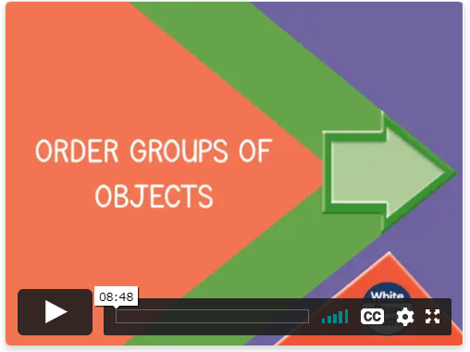  https://whiterosemaths.com/homelearning/year-1/week-12-number-place-value-within-20/ | Maths  Order numbers 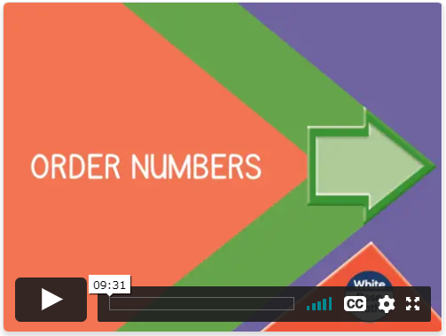  https://whiterosemaths.com/homelearning/year-1/week-12-number-place-value-within-20/
10am |  | Break | Break | Break | Break
10.20am |  | Phonics  Recap your sounds for the set that you are on and write some words with those sounds in them.  (Please email your class teacher if you are unaware of what set of sounds your child is currently working on) | Phonics  Teach Your Monster to Read Phonics Online Learning App.  (You should have been given your online logins – contact class teacher if unsure) | Phonics  Recap your sounds for the set that you are on and write some words with those sounds in them.  (Please email your class teacher if you are unaware of what set of sounds your child is currently working on) | Phonics  Teach Your Monster to Read Phonics Online Learning App.  (You should have been given your online logins – contact class teacher if unsure)
10.50am |  |  | English  New book – Back to Earth with a Bump.  file:///F:/Corona%20WFH/Timetables/Week%205%20-%20wc%2020.4.20/Back%20to%20earth%20with%20a%20bump%20.pdf  Look at the front cover (read the title, look at the pictures) make a prediction about what you think the book is about. Give reasons for your prediction using the word ‘because’ to explain. | English  Back to Earth with a Bump.  file:///F:/Corona%20WFH/Timetables/Week%205%20-%20wc%2020.4.20/Back%20to%20earth%20with%20a%20bump%20.pdf  Read pages 1 & 2. Write a character description about the main character Hal.  Remember to use exciting adjectives to describe Hal and to use the pronoun ‘he’. | English  Back to Earth with a Bump.  file:///F:/Corona%20WFH/Timetables/Week%205%20-%20wc%2020.4.20/Back%20to%20earth%20with%20a%20bump%20.pdf  Read pages 3 & 4. Write a setting description of when Hal’s bed is in the sky.  Remember to use exciting adjectives to describe the setting.
11.30am |  | Lunch | Lunch | Lunch | Lunch
12.30pm |  | Reading  Bug Club Reading app (Active Learn)  Usernames and passwords have been given out.  Email teacher if unsure. | Reading  Bug Club Reading app (Active Learn)  Usernames and passwords have been given out.  Email teacher if unsure. | Reading  Bug Club Reading app (Active Learn)  Usernames and passwords have been given out.  Email teacher if unsure. | Reading  Bug Club reading app (Active Learn)  Usernames and passwords have been given out.  Email teacher if unsure.
12.50pm |  | PE  Joe Wicks workout  https://www.youtube.com/channel/UCAxW1XT0iEJo0TYlRfn6rYQ | PE  Joe Wicks workout  https://www.youtube.com/channel/UCAxW1XT0iEJo0TYlRfn6rYQ | PE  Joe Wicks workout  https://www.youtube.com/channel/UCAxW1XT0iEJo0TYlRfn6rYQ | PE  Joe Wicks workout  https://www.youtube.com/channel/UCAxW1XT0iEJo0TYlRfn6rYQ
1.20pm |  | Art  Can you create different types of line (wavy, straight, zig-zag, vertical, horizontal) using different drawing materials e.g. pencil, colouring pencil, pen, felt tips, paint, chalk, charcoal.  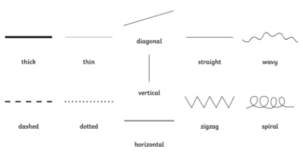 | Activity- Obstacle course  Create it in any way you see fit. Things like cones to run in and out of, hoops to jump in, a start and finish line for skipping, Spots to jump on, hurdles to jump over etc | Art  Can you draw an animal and use colour, line and shape? | Activity- Scavenger hunt- Natural materials.  Children could be encouraged to collect things from the outdoor area of their bubble like grass, branches and leaves, they could then make a collage using these things.  Feel free to send us pictures!
2. 45pm – 3.15pm |  | Cosmic Kids Yoga Adventure – We’re going on a bear hunt.  https://www.youtube.com/watch?v=KAT5NiWHFIU | Free audible books – select a book to read. Relax and enjoy.  https://stories.audible.com/discovery | Zen Den – Mindfulness for kids.  https://www.youtube.com/watch?v=so8QN9an3t8 | Cosmic Kids Yoga Adventure – We’re going on a bear hunt.  https://www.youtube.com/watch?v=KAT5NiWHFIU

Your year group teachers will be available to reply to emails between 9am and 3pm Monday – Friday. During this time, they will be working on other school priorities as well, so you may not get an emailed reply straight away.

Mrs Trapani - Head of KS1 luisa.trapani@rydersgreen.sandwell.sch.uk  Miss Hartley - Teacher 1H siobhan.hartley@rydersgreen.sandwell.sch.uk  Miss Fiaz – Teacher 1F samia.fiaz@rydersgreen.sandwell.sch.uk | Mrs Begum – TA salma.begum@rydersgreen.sandwell.sch.uk  Miss Corbett- TA danielle.corbett@rydersgreen.sandwell.sch.uk  Angela Johal – Technical Support – angela.johal@rydersgreen.sandwell.sch.uk

