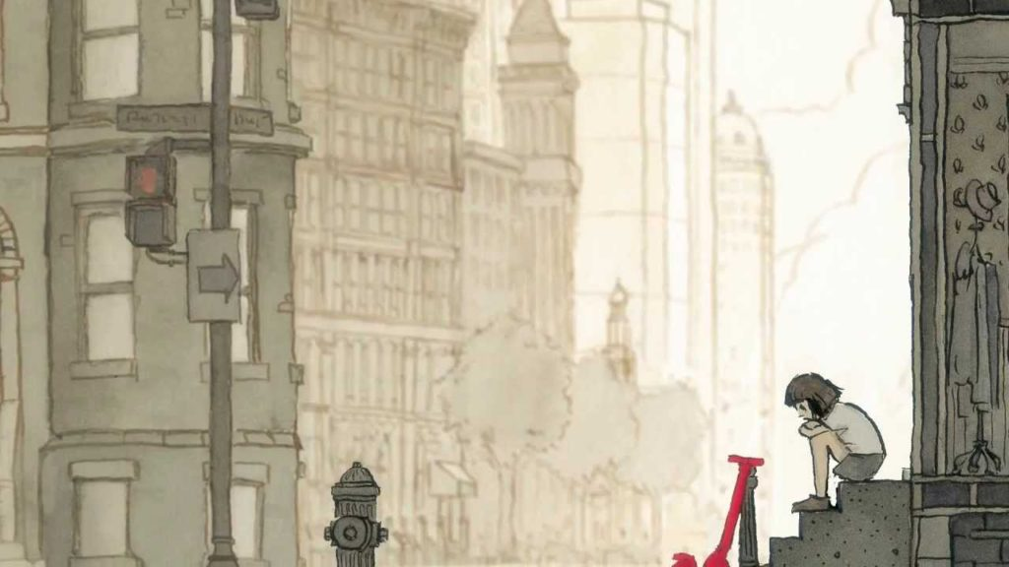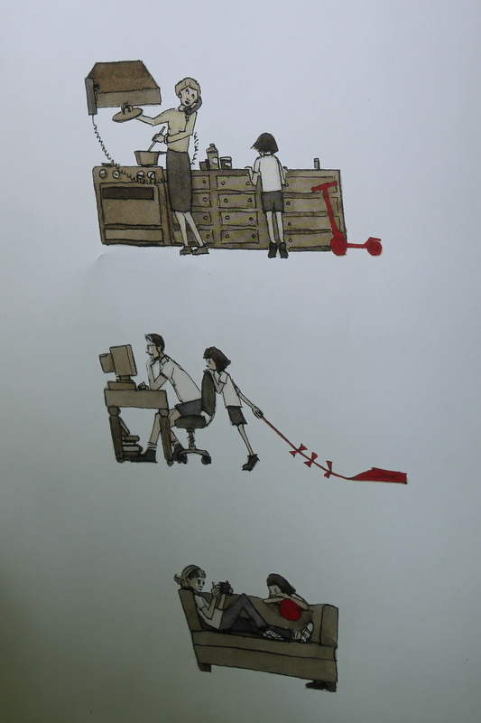
Inference: Use the clues in the picture to say what you think the likely answer would be.
Think about the clues you can see in this picture to help you answer these question. Write the answers down or type your answers into your computer.
- What emotions do you think the girl is feeling? How can we tell?
- Why do you think she is sat outside on the steps scrunched up?
- What can we tell about the other characters from their body language?
- Why do you think Aaron Becker has chosen to show what is going on inside the house?
- Why do you think somethings have been drawn in colour?
- What might happen to these characters in a story?

