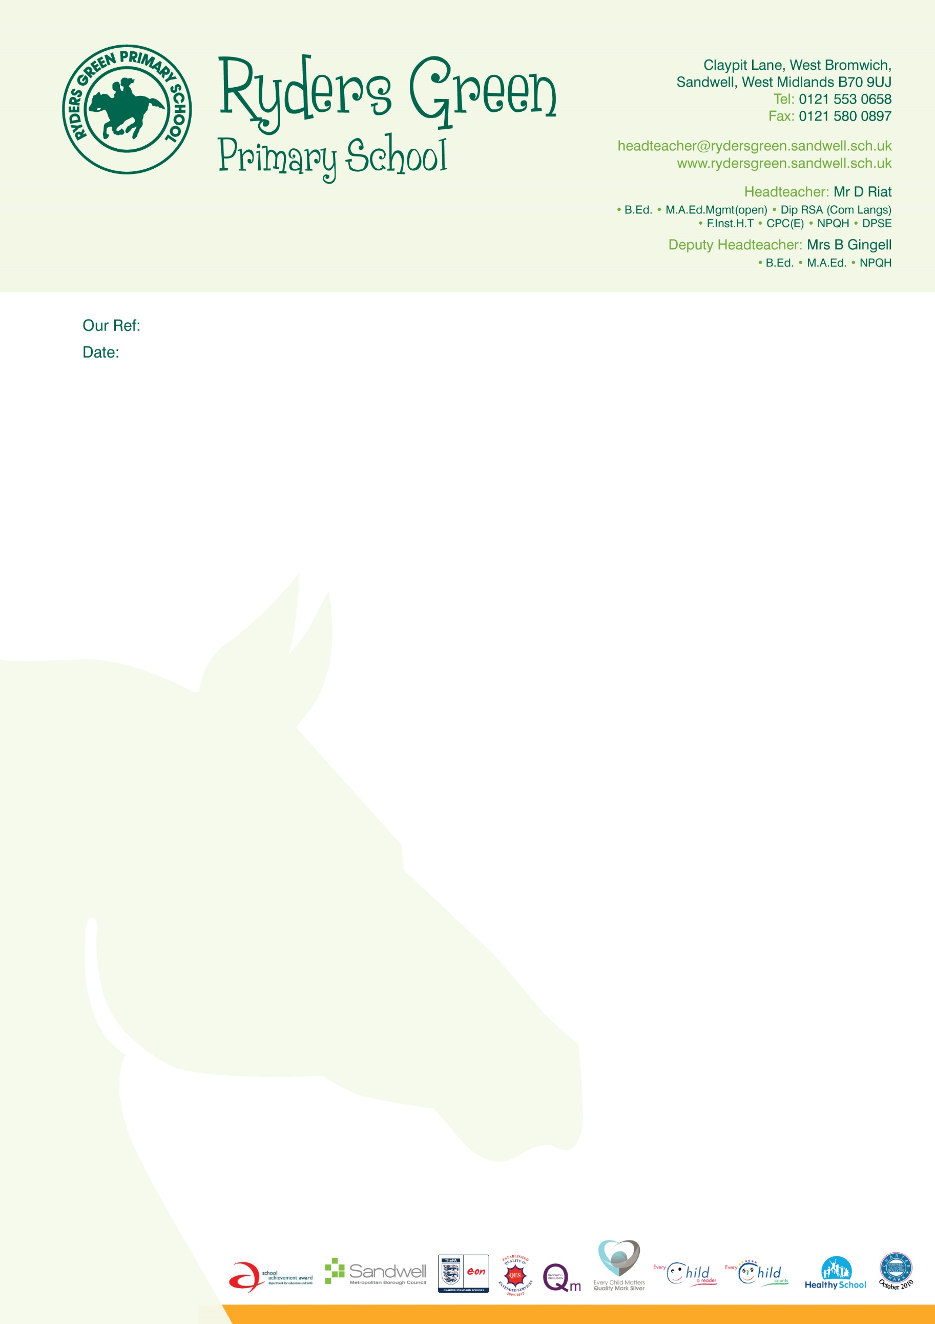





LB/AJ

30 March 2022

Dear Parent/Carer,

As you are aware, we have appointed Dolce Catering as our new meal provider. Dolce will start to provide your child with a meal from Friday 1st April 2022.

It is very important you activate your School Grid accounts before Friday, as you will be required to pre-order your child's meal from home.

This also applies to all the children who are currently entitled to a free school meal and KS1 Universal meal in Reception, Year 1 and Year 2.

You will need to ensure you have added 'Allergies' that apply to your child within School Grid.

The activation link has been sent to your email accounts that you have provided the school. Please check your junk/spam folders.

Do not use ParentPay to pay for meals as of 1st April.

If you require any assistance with School Grid or School Meals please contact:

**Dolce Customer Care** on 01942 707709 or email to [customercare@dolce.co.uk](mailto:customercare@dolce.co.uk)

**School Grid Technical Support** on 01506 300310 or email to [support@schoolgrid.co.uk](mailto:support@schoolgrid.co.uk)

Alternatively contact the school office.

If you do not wish for your child to have a school meal, please send a packed lunch.

Thank you for your continued support.

Kind regards

Lucy Blackmore

Headteacher

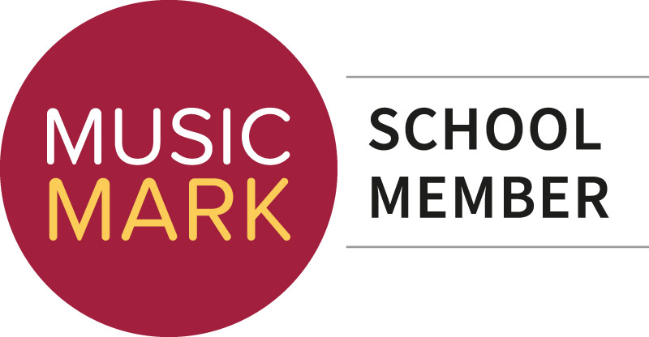

**Head Teacher:** Miss L Blackmore

🞟 Ba (Hons) 🞟 QTS 🞟 Pg Cert 🞟 AST

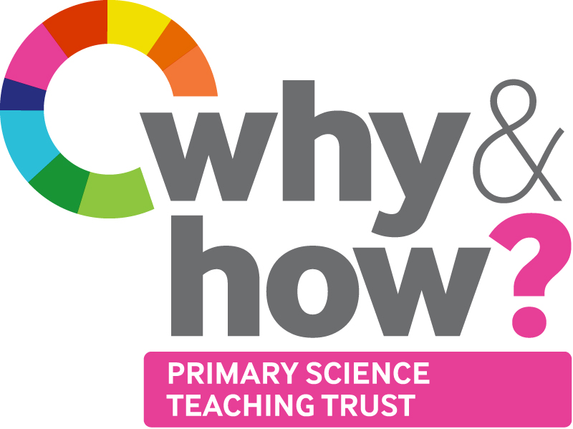

**www.rydersgreenprimary.co.uk**

**Contactus@rydersgreen.sandwell.sch.uk**